**Class: CSE 3330-001**

**Project: Project 1-Phase 2**

Semester: **Summer 2022**

**Student Name1: Aditya Mishra**

**StudentID1: 1001663720**

**StudentName2: Jose Aguilar**

**StudentID2: 1001128942**

**Professor Name: Dr. Bhanu Jain**

**I pledge, on my honor, to uphold UT Arlington's tradition of academic integrity, a tradition that values hard work and honest effort in the pursuit of academic excellence.**

**I promise that I will submit only work that I personally create or that I contribute to group collaborations, and I will appropriately reference any work from other sources. I will follow the highest standards of integrity and uphold the spirit of the Honor Code.**

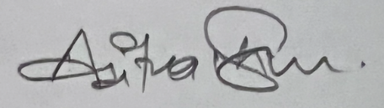 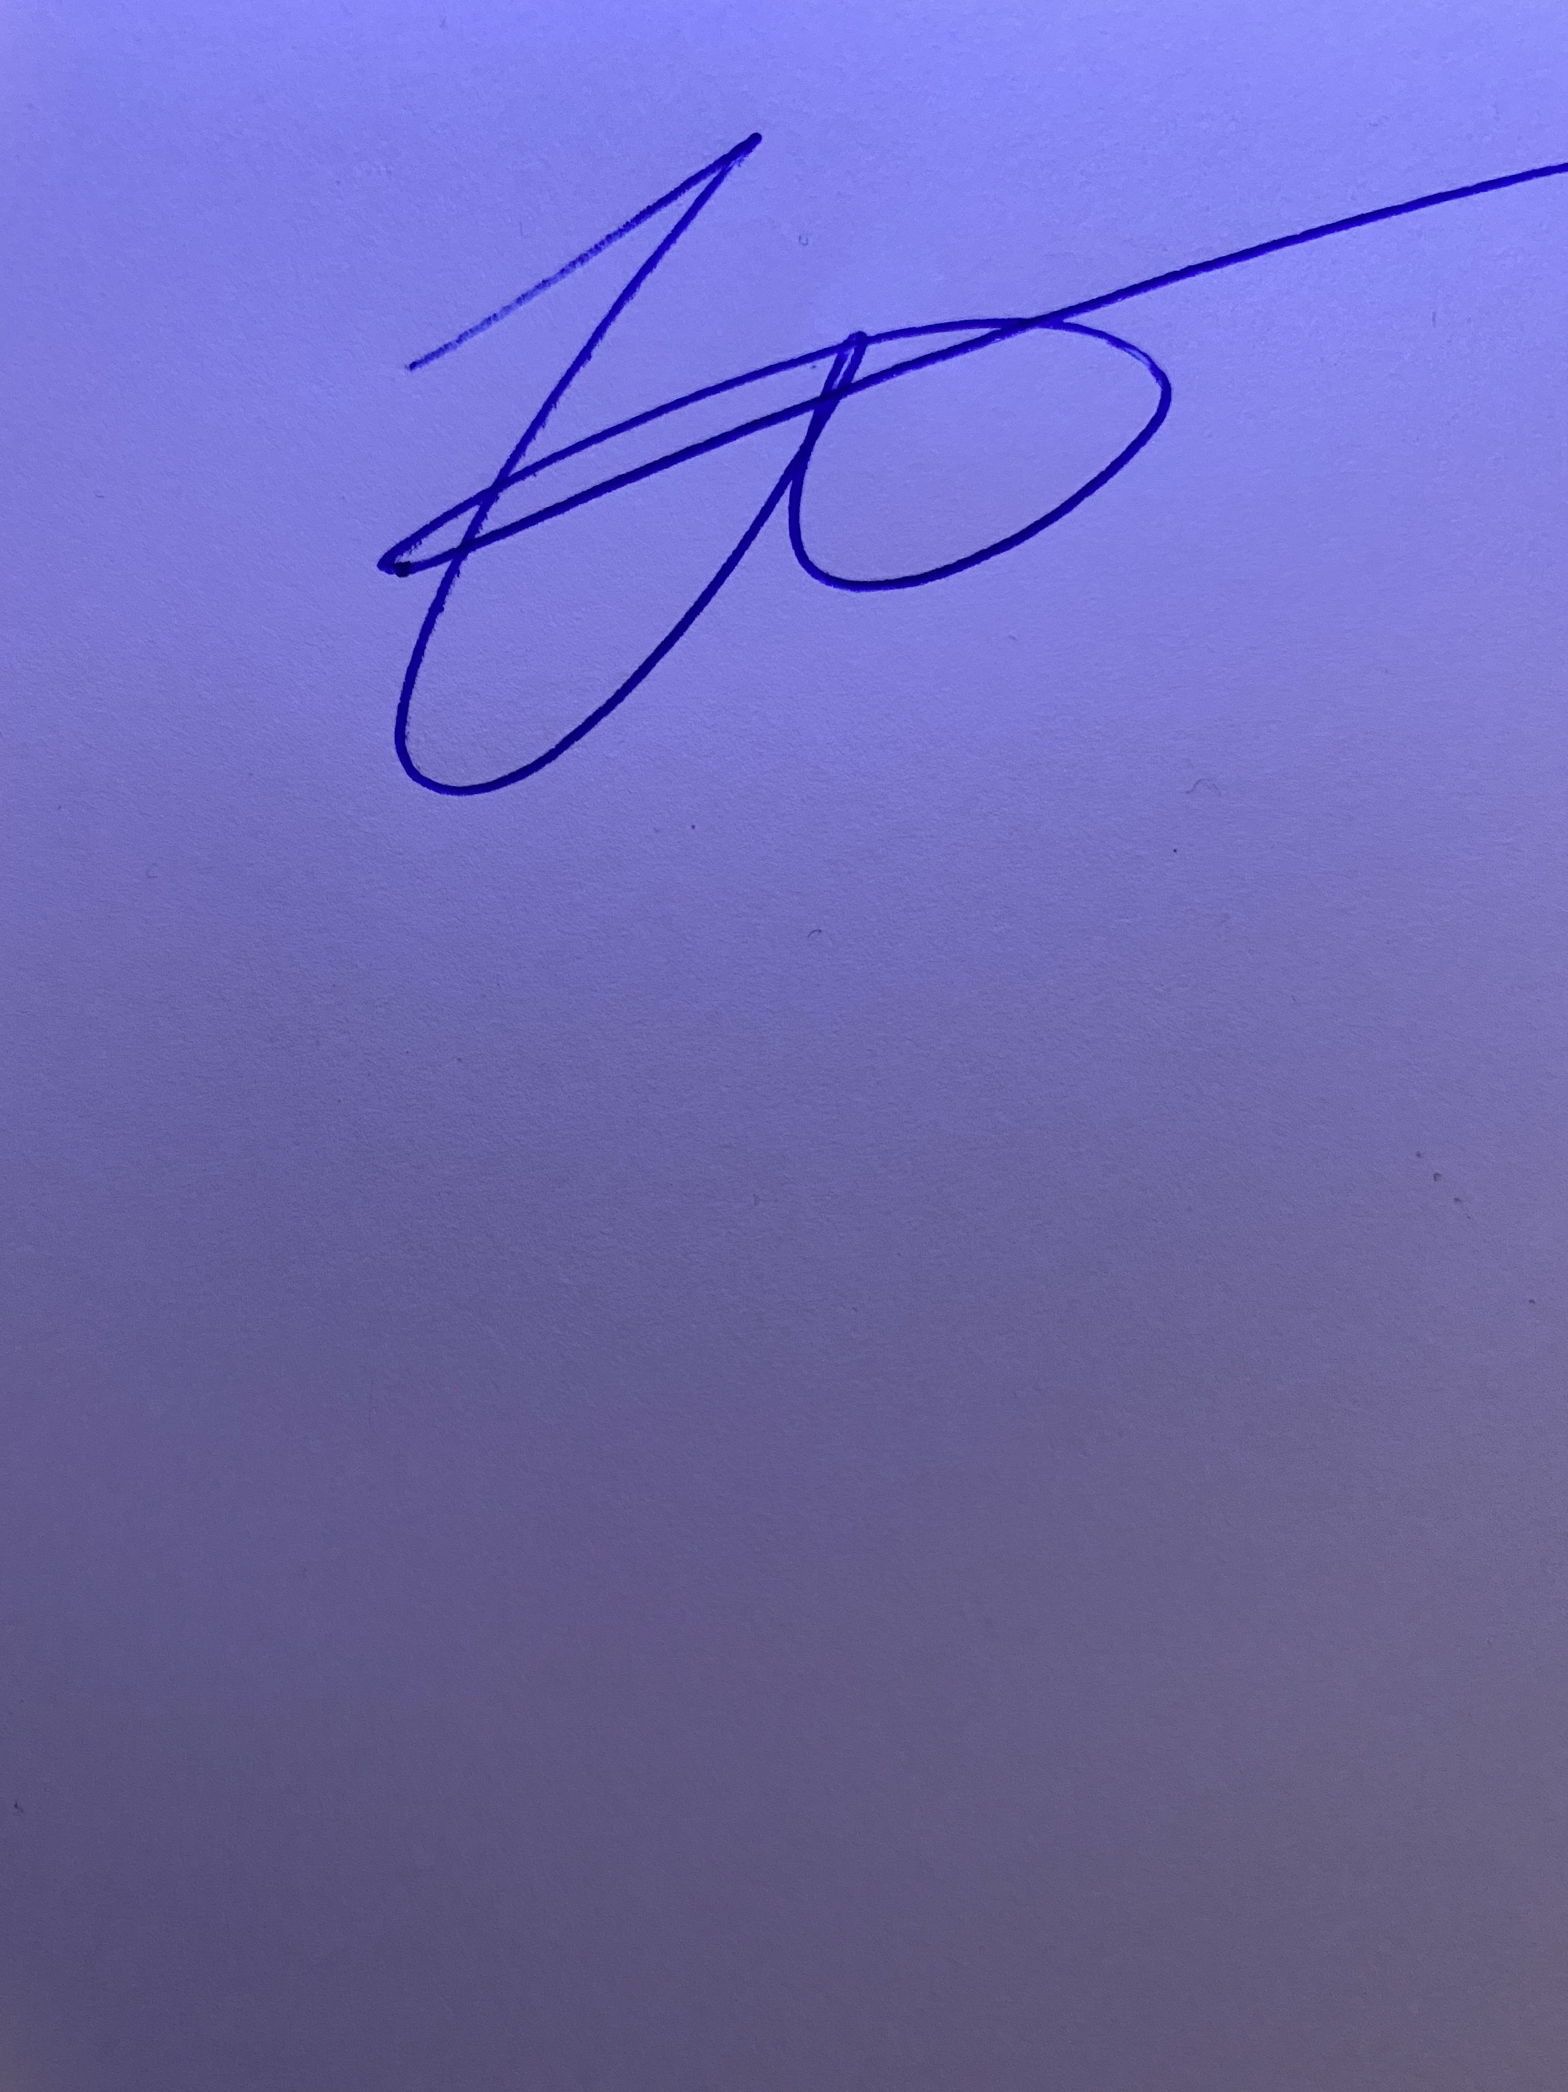

**________________ _______________**

**Aditya Mishra Jose Aguilar**

**Part 1 Doctoral Database**

**NOTE:**

**Please check the note before Grading.**

1. **All the codes for SQL are in the picture.**
2. **Most of the parts where there are many entries like 100 or more. We have included pictures of at least 25 entries.**
3. **We Also got a day extension from the professor.**
4. **We have code, code executed, datasets uploaded and logs for all the database tables in the file.**

ALL the different queries are shown.

Logs of all the database tables created while coding.

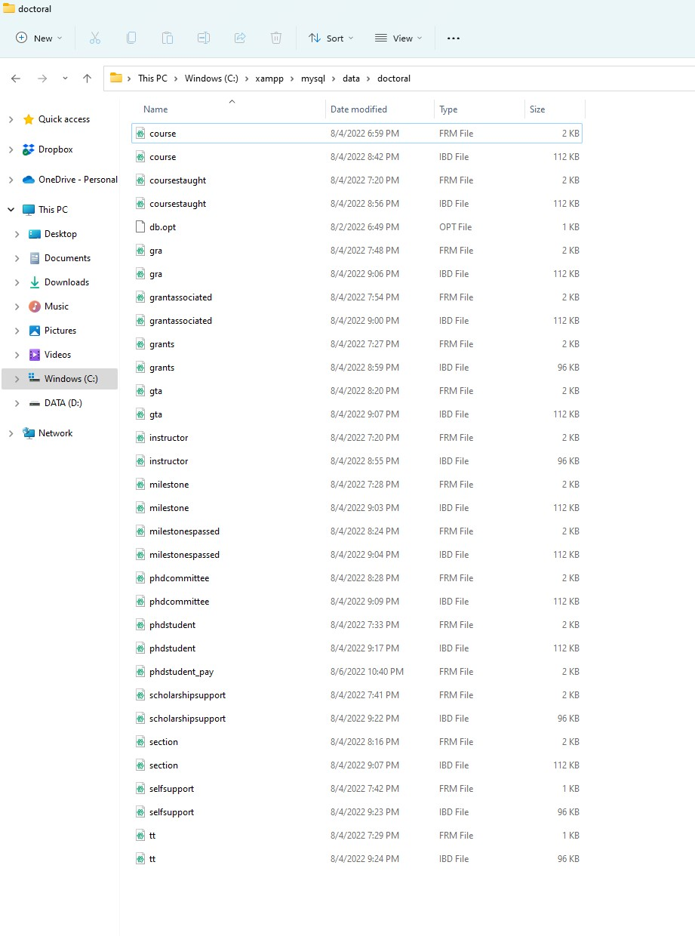

CODE FOR INSTRUCTOR

1. INSTRUCTOR

Code:

CREATE TABLE INSTRUCTOR

(InstructorId CHAR(6) NOT NULL,

FName VARCHAR(20) NOT NULL,

LName VARCHAR(20) NOT NULL,

StartDate DATE,

Degree VARCHAR(10) NOT NULL,

RANK VARCHAR(20) NOT NULL,

TYPE VARCHAR(8) NOT NULL,

PRIMARY KEY(InstructorId));

Code executed

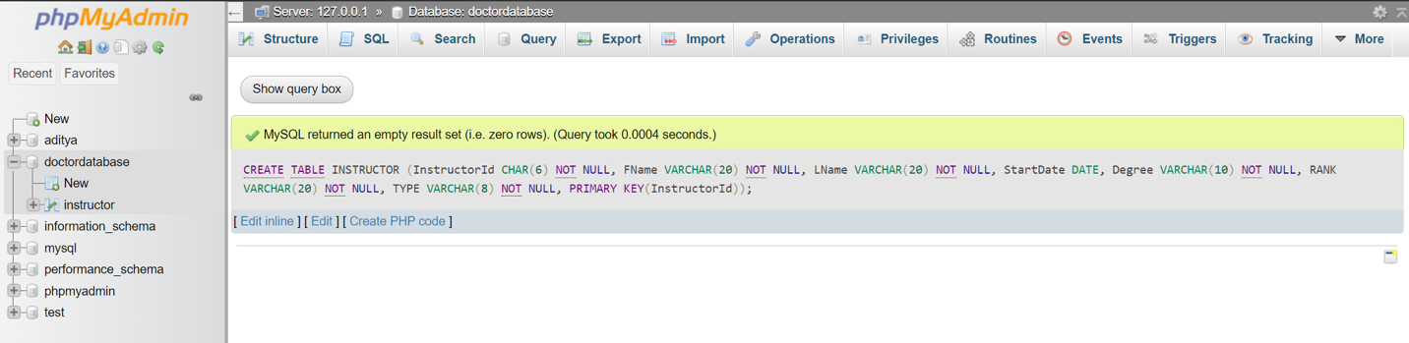

Dataset uploaded

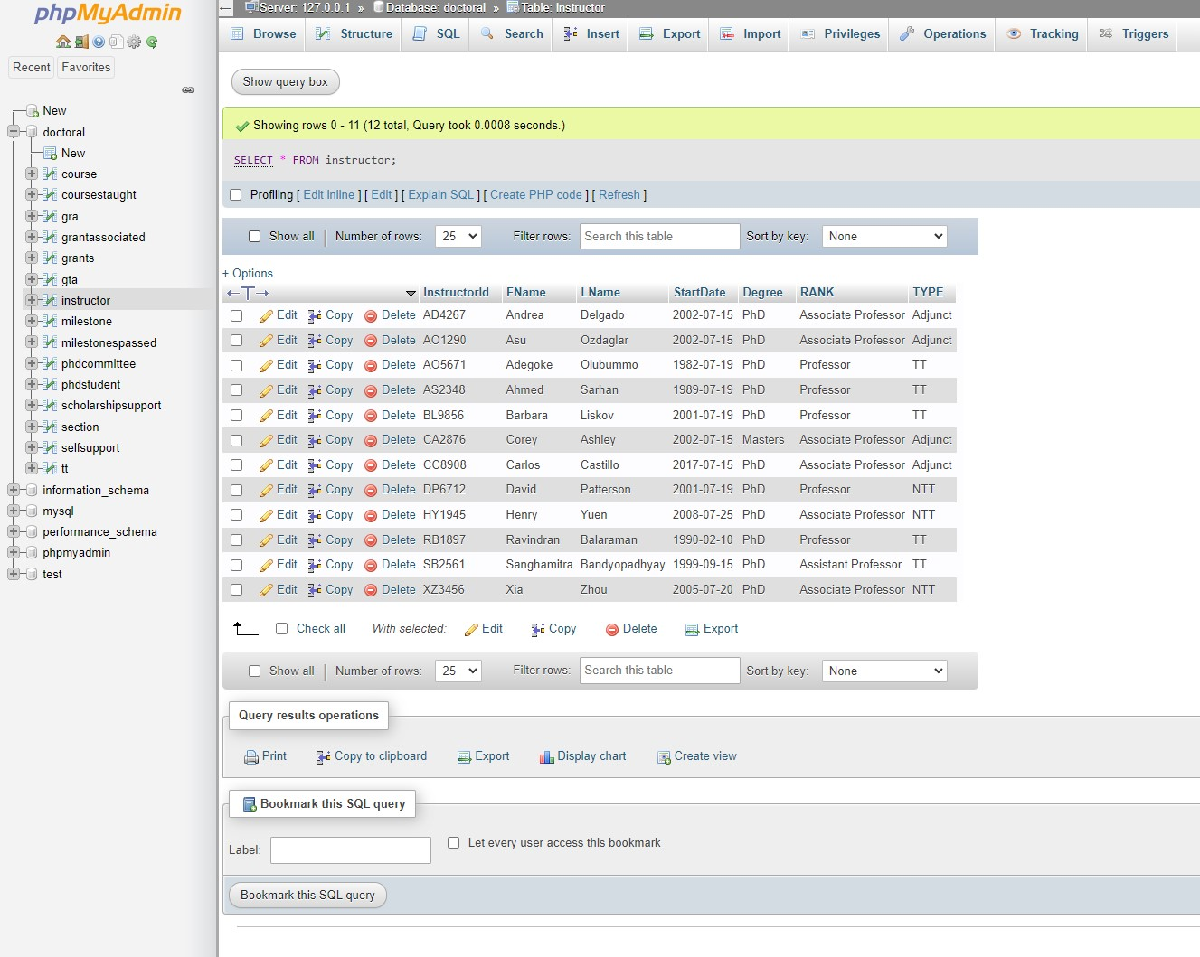

1. TT

Code:

CREATE TABLE TT

(InstructorId CHAR(6) NOT NULL,

NoOfPhDStudents INT NOT NULL,

PRIMARY KEY (InstructorId,NoOfPhDStudents),

CONSTRAINT TTINSFK

FOREIGN KEY (InstructorId) REFERENCES INSTRUCTOR (InstructorId)

ON DELETE CASCADE ON UPDATE CASCADE);

Code executed: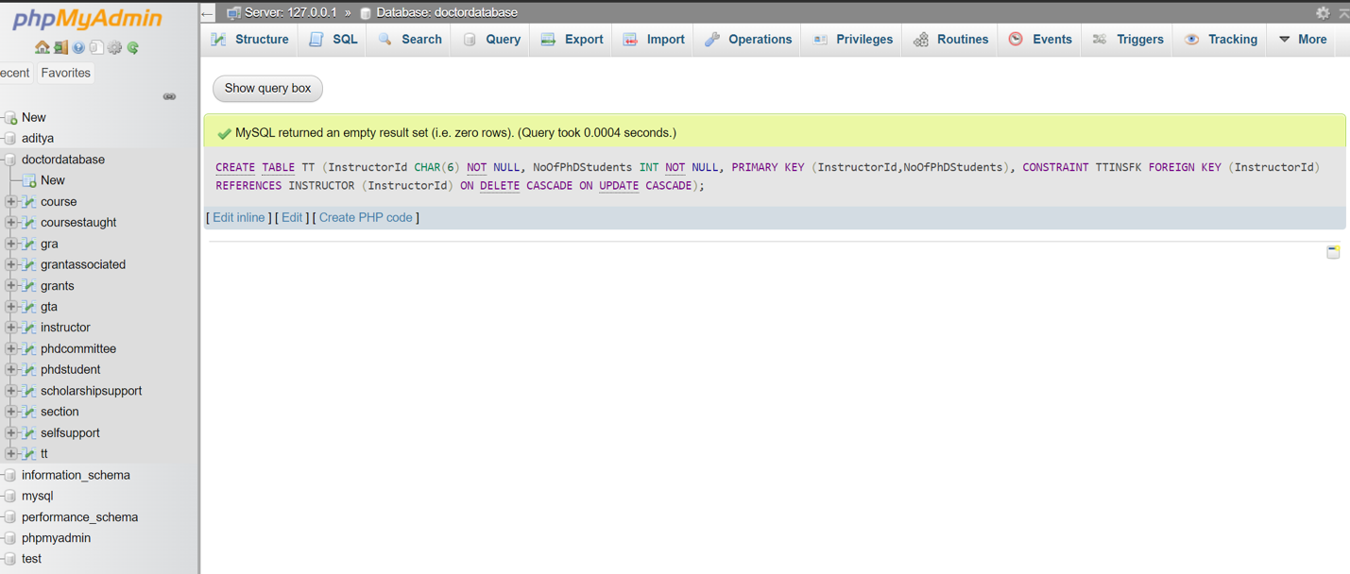

Dataset updated:

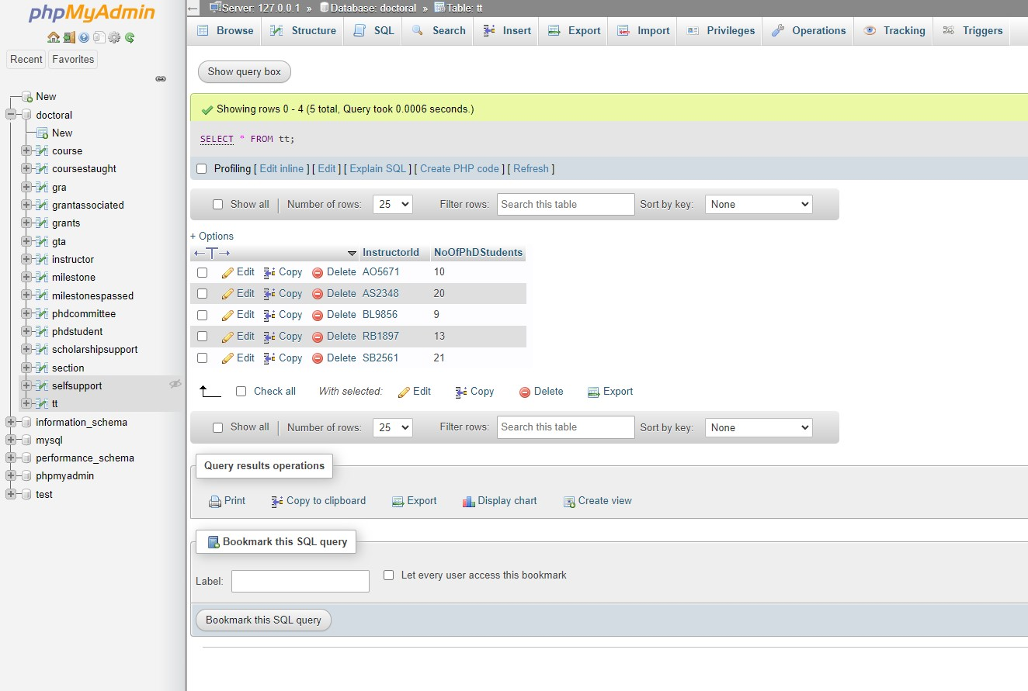

1. PHDSTUDENT

Code:

CREATE TABLE PHDSTUDENT

(StudentId CHAR(6) NOT NULL,

FName VARCHAR(20) NOT NULL,

LName VARCHAR(30) NOT NULL,

StSem VARCHAR(8) NOT NULL,

StYear CHAR(4) NOT NULL,

Supervisor CHAR(6) NOT NULL,

PRIMARY KEY (StudentId),

CONSTRAINT PHDSTUINSFK

FOREIGN KEY (Supervisor) REFERENCES INSTRUCTOR (InstructorId)

ON DELETE CASCADE ON UPDATE CASCADE);

Code Executed:

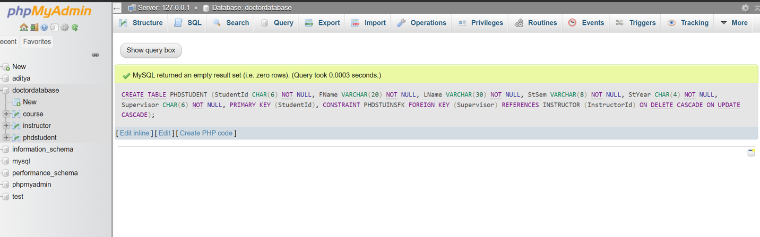

Dataset uploaded:

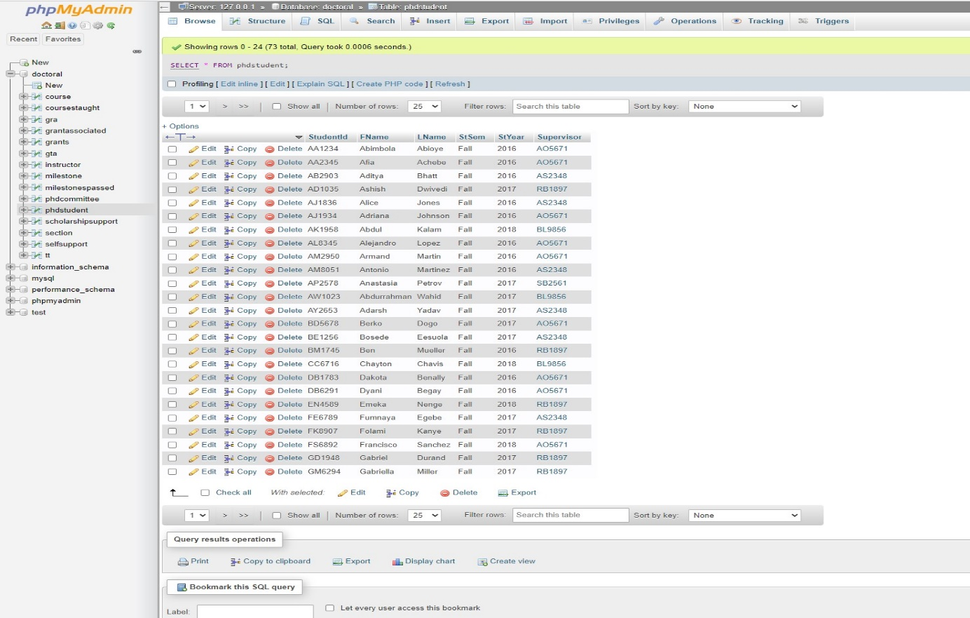

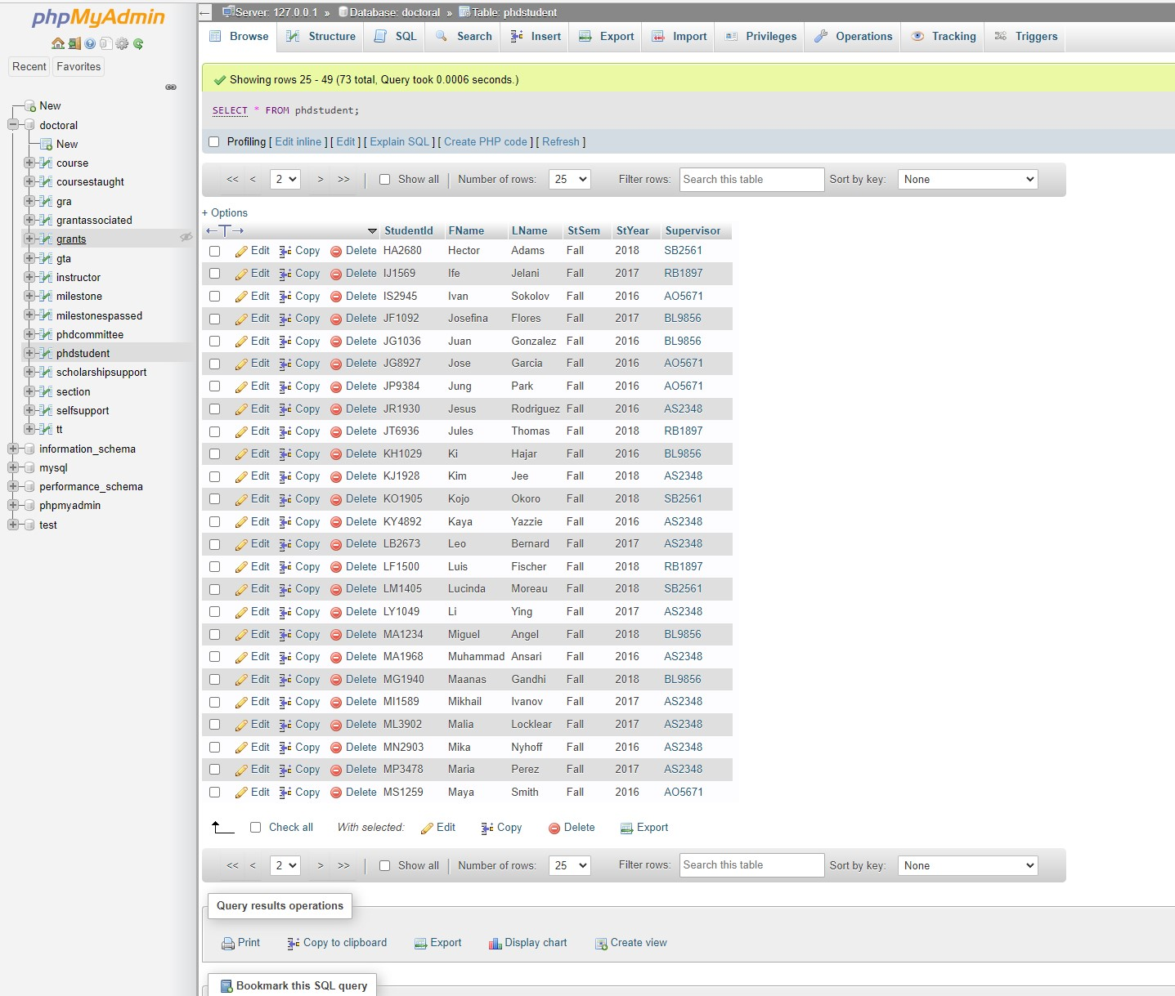

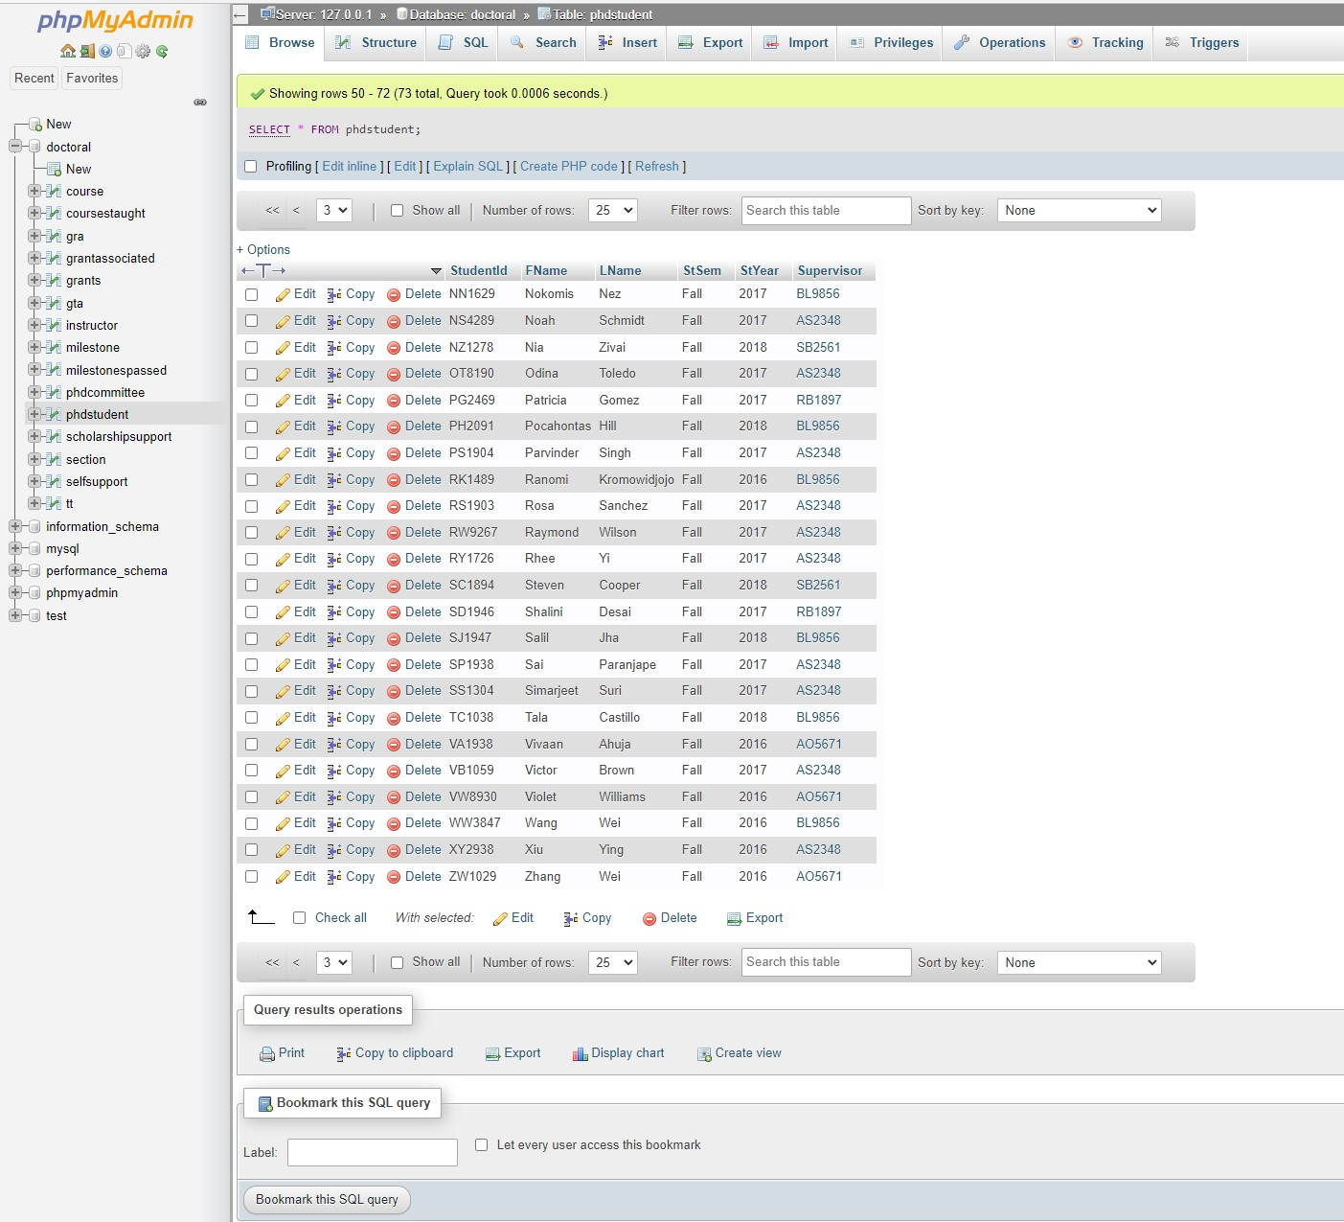

1. GTA

Code:

CREATE TABLE GTA

(SectionId CHAR(11) NOT NULL,

MontlyPay DECIMAL(10,2),

StudentId CHAR(6) NOT NULL,

PRIMARY KEY (SectionId, StudentId),

CONSTRAINT GTASECFK

FOREIGN KEY (SectionId) REFERENCES SECTION (SectionId)

ON DELETE CASCADE ON UPDATE CASCADE,

CONSTRAINT GTAPHDSFK

FOREIGN key (StudentId) REFERENCES PHDSTUDENT (StudentId)

ON DELETE CASCADE ON UPDATE CASCADE);

Code Executed:

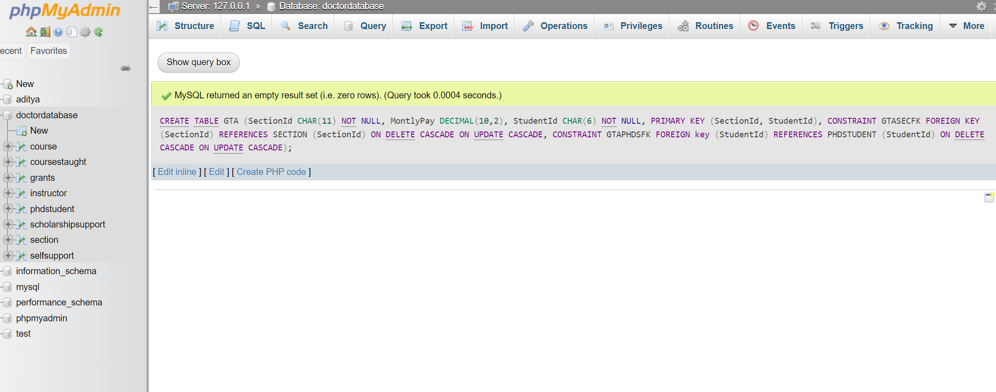

Datasets Uploaded:

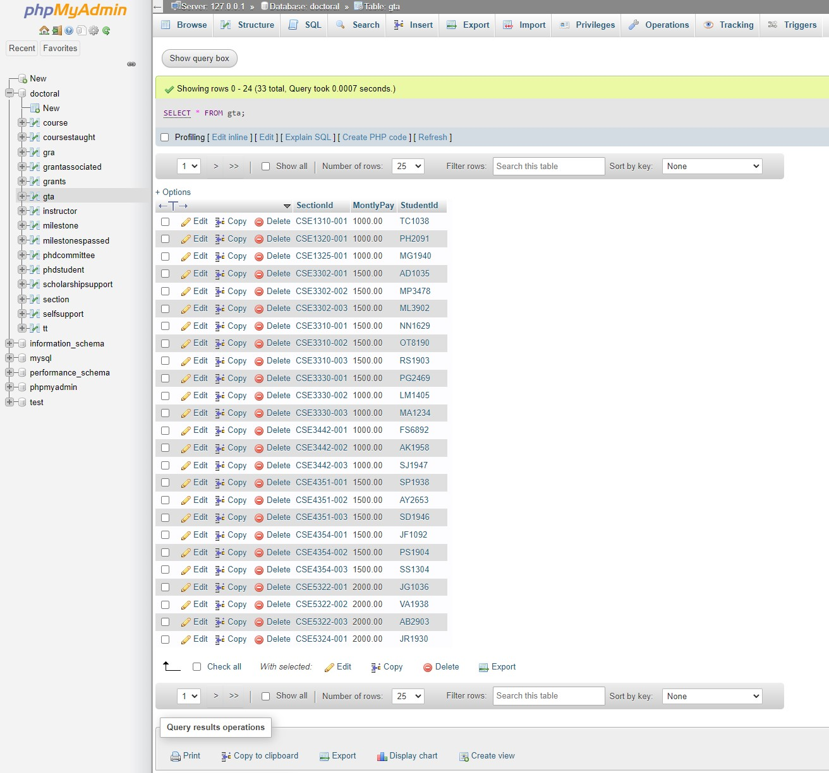

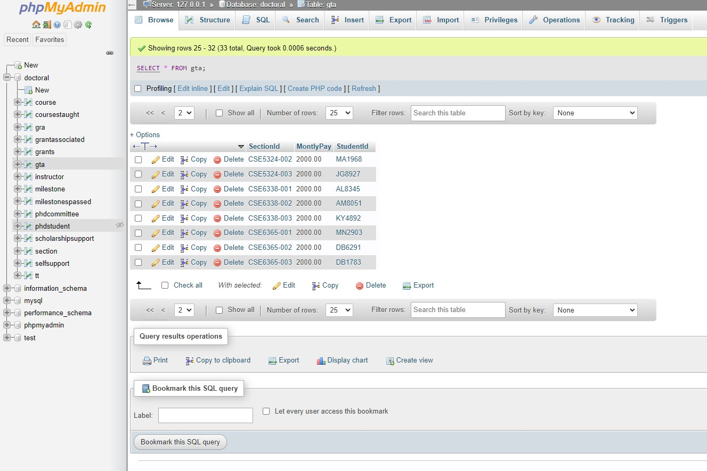

\

1. GRA

Code:

CREATE TABLE GRA

(StudentId CHAR(6) NOT NULL,

AccountNo CHAR(4) NOT NULL,

MonthlyPay DECIMAL(10,2),

PRIMARY KEY (StudentId, AccountNo),

CONSTRAINT GRPHSTFK

FOREIGN KEY (StudentId) REFERENCES PHDSTUDENT (StudentId)

ON DELETE CASCADE ON UPDATE CASCADE,

CONSTRAINT GRAGRFK

FOREIGN KEY (AccountNo) REFERENCES GRANTS (AccountNo)

ON DELETE CASCADE ON UPDATE CASCADE);

code executed:

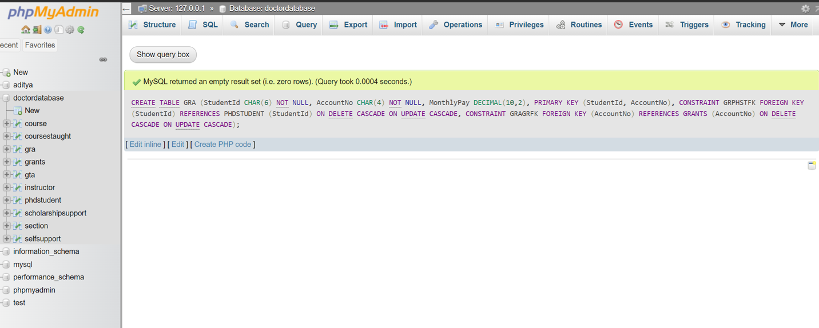

Dataset uploaded:

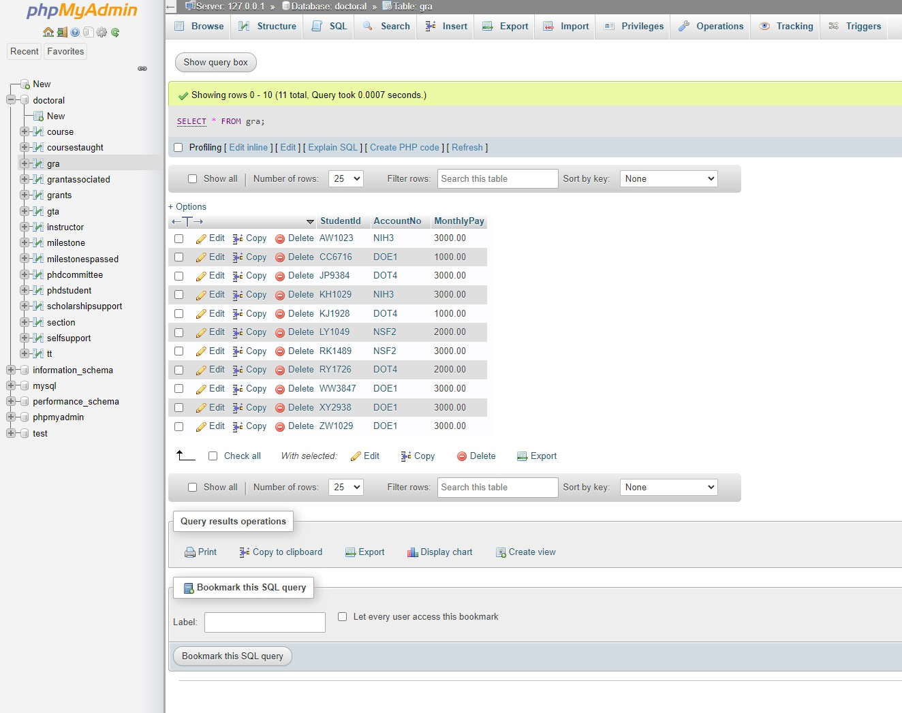

6. SELFSUPPORT

CREATE TABLE SELFSUPPORT

(StudentId CHAR(6) NOT NULL,

PRIMARY KEY (StudentId),

CONSTRAINT SELFSSTFK

FOREIGN KEY (StudentId) REFERENCES PHDSTUDENT (StudentId)

ON DELETE CASCADE ON UPDATE CASCADE);

Code executed

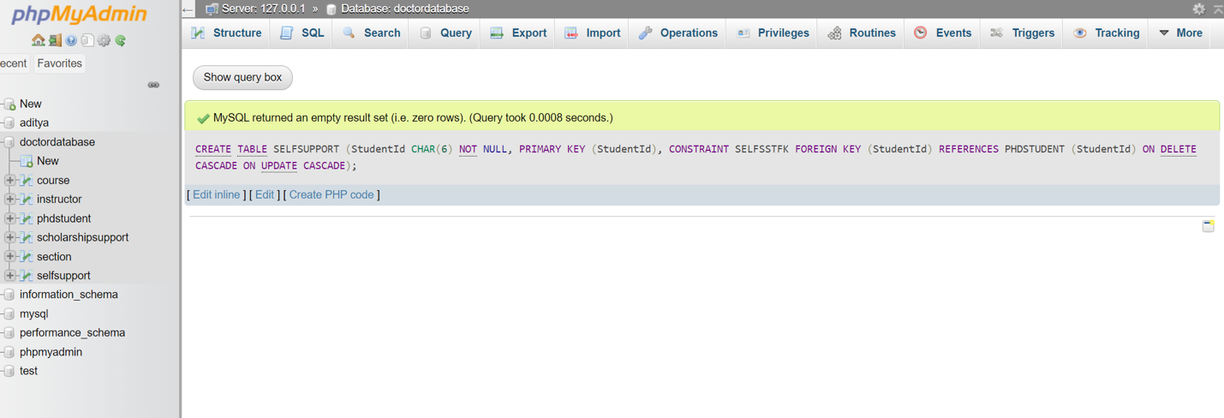

Dataset uploaded:

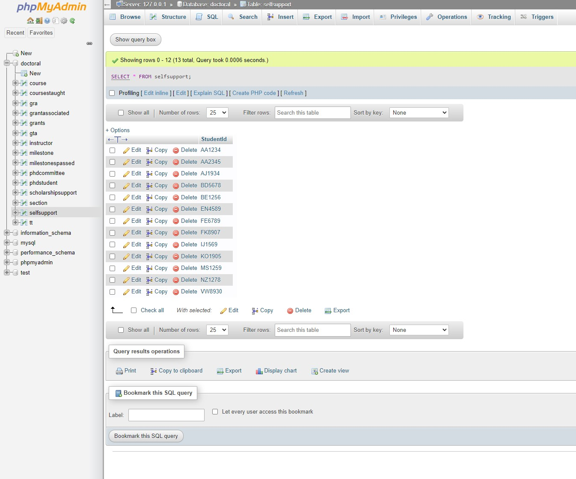

7.  SCHOLARSHIPSUPPORT

Code:

CREATE TABLE SCHOLARSHIPSUPPORT

(StudentId CHAR(6) NOT NULL,

Type VARCHAR(15),

Sourcee VARCHAR(15),

PRIMARY KEY (StudentId),

CONSTRAINT SCSUPSTUFK

FOREIGN KEY (StudentId) REFERENCES PHDSTUDENT (StudentId)

ON DELETE CASCADE ON UPDATE CASCADE);

Code Executed:

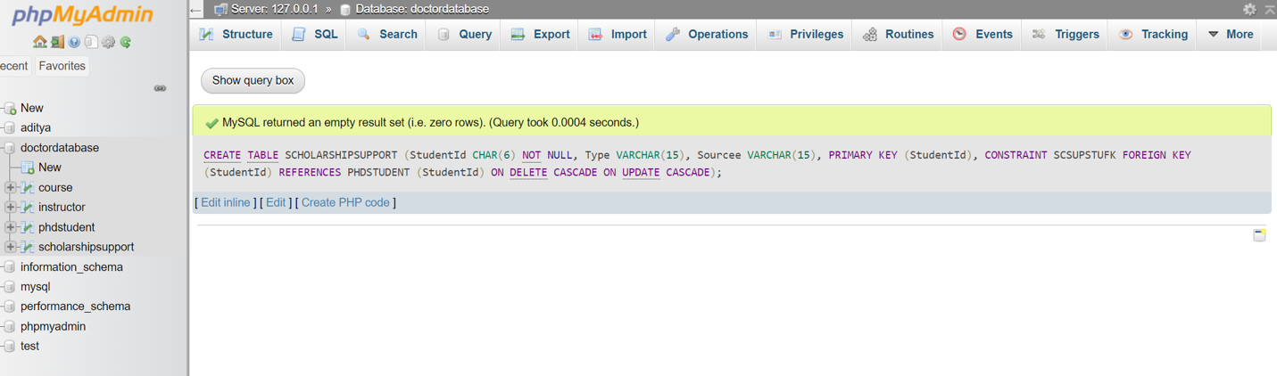

Datasets uploaded:

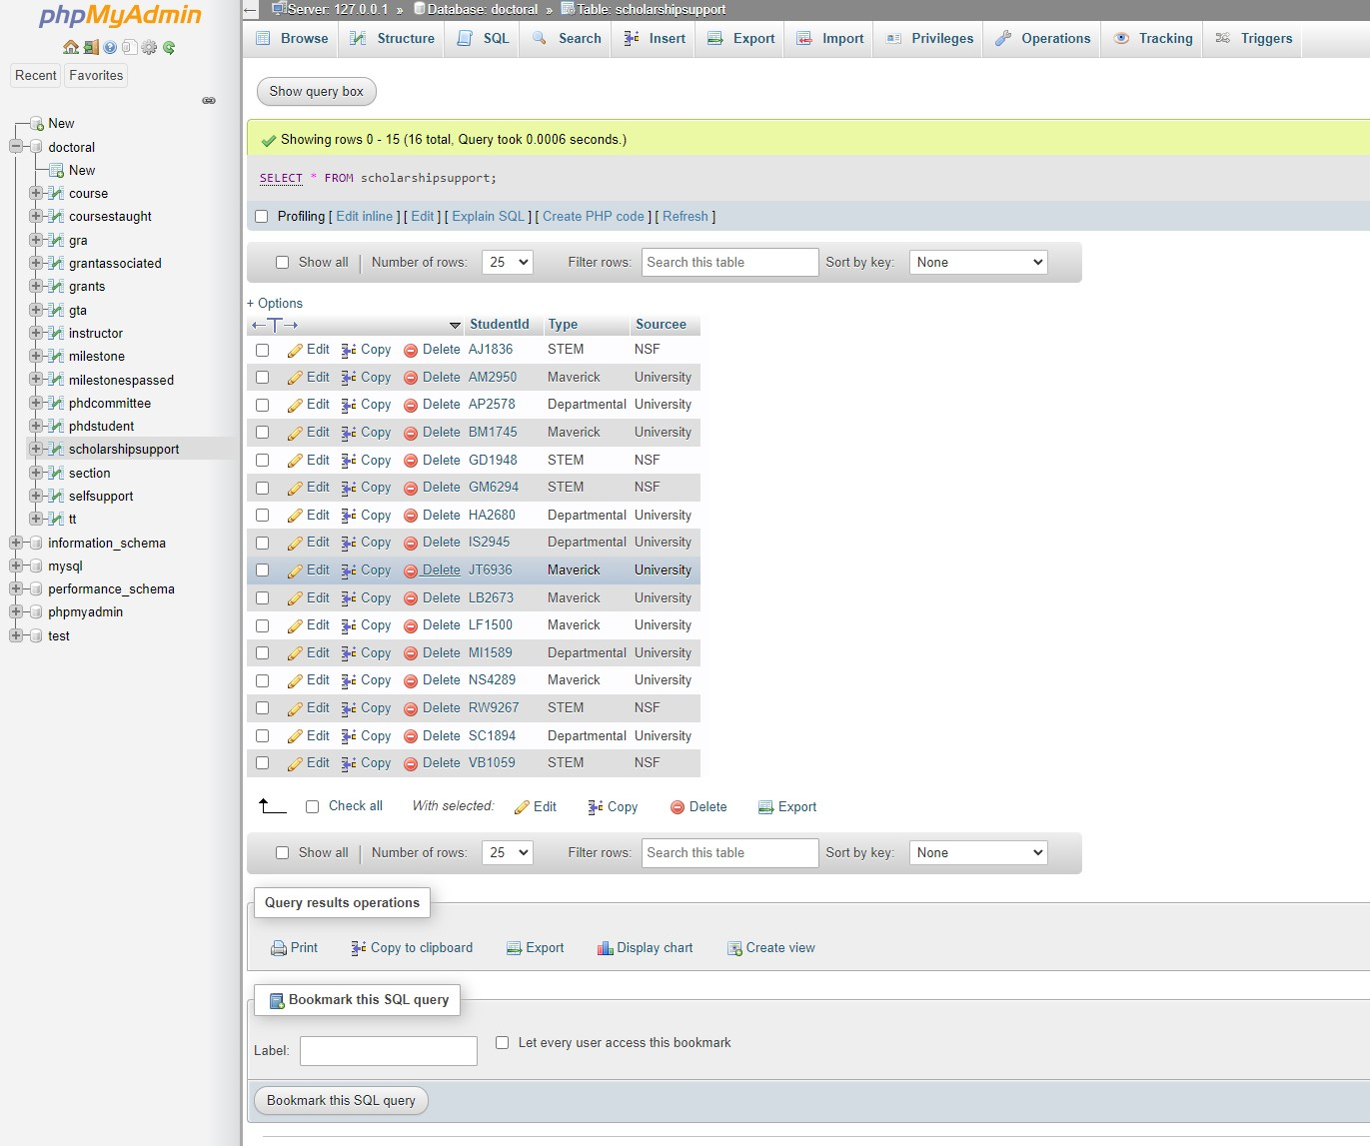

8. COURSE

Code:

CREATE TABLE COURSE

(CourseId CHAR(7) NOT NULL,

CName VARCHAR(45) NOT NULL,

PRIMARY KEY (CourseId),

UNIQUE(CName));

Code Executed:

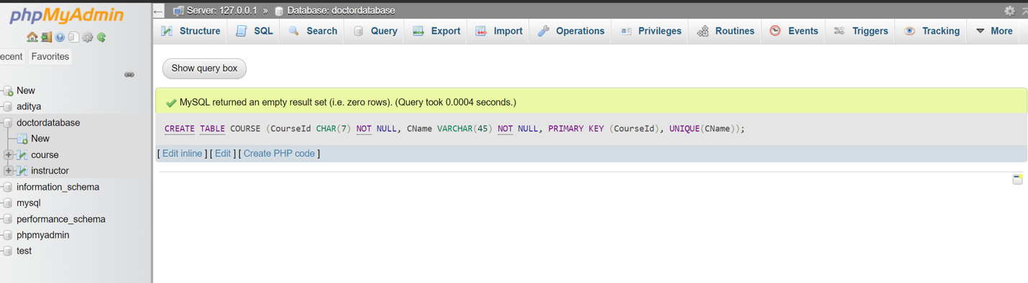

Dataset uploaded:

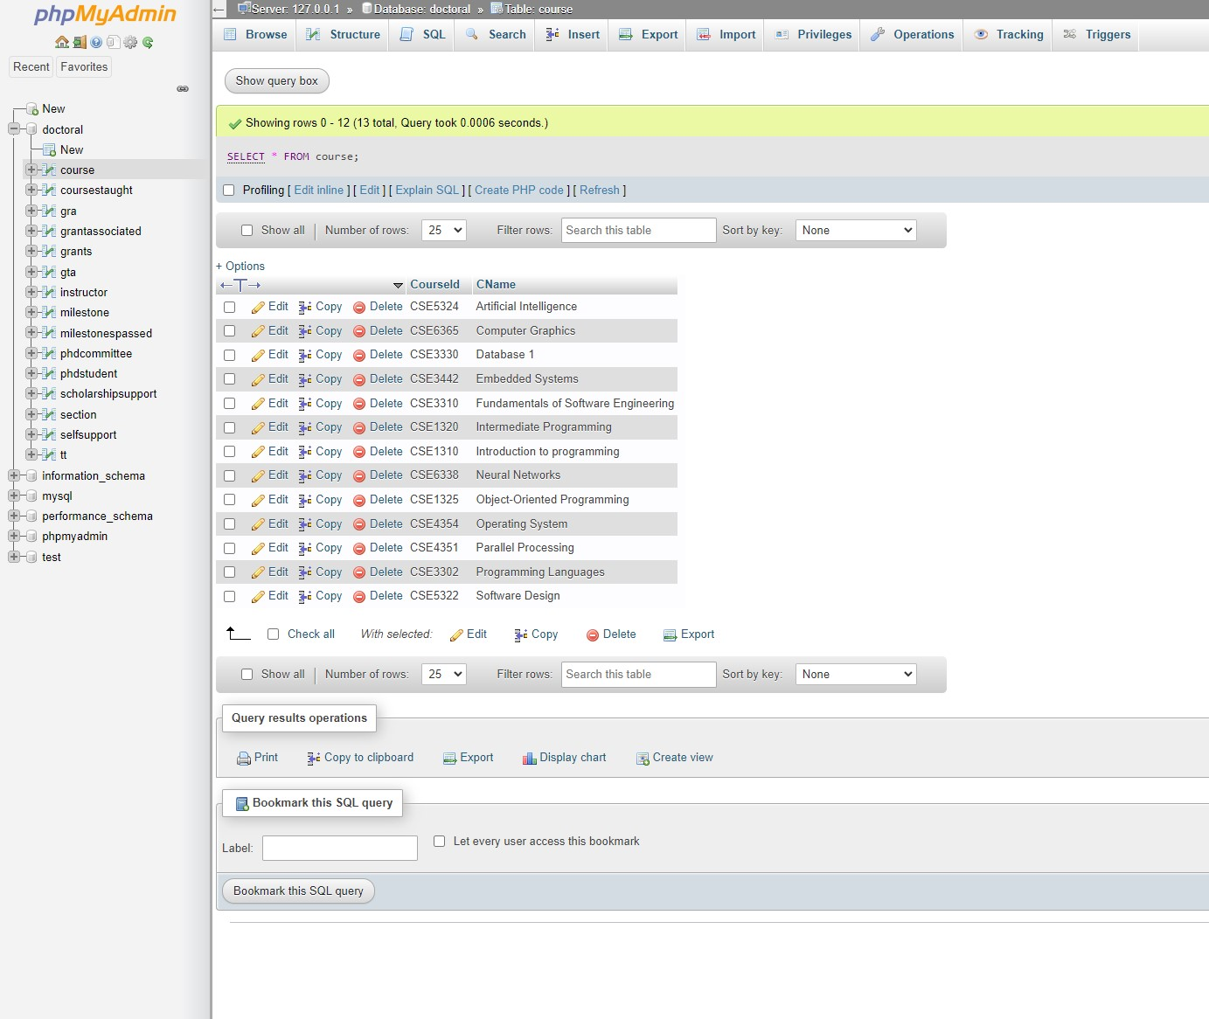

9. SECTION

Code:

CREATE TABLE SECTION

(SectionId VARCHAR(12) NOT NULL,

CourseId CHAR(7) NOT NULL,

PRIMARY KEY (SectionId),

CONSTRAINT SECCOURFK

FOREIGN KEY (CourseId) REFERENCES COURSE (CourseId)

ON DELETE CASCADE ON UPDATE CASCADE);

Code executed:

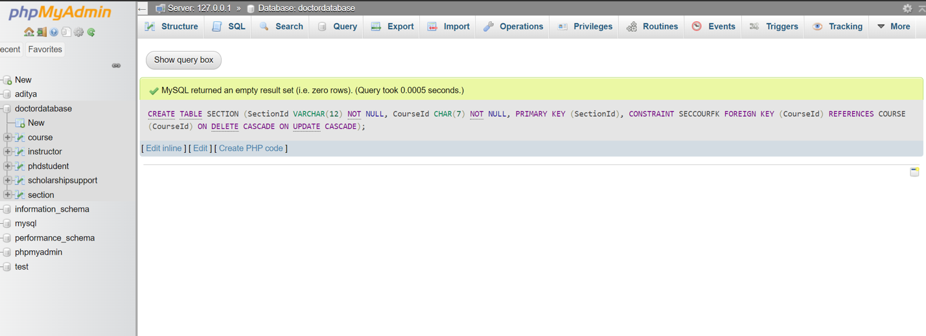

Dataset uploaded:

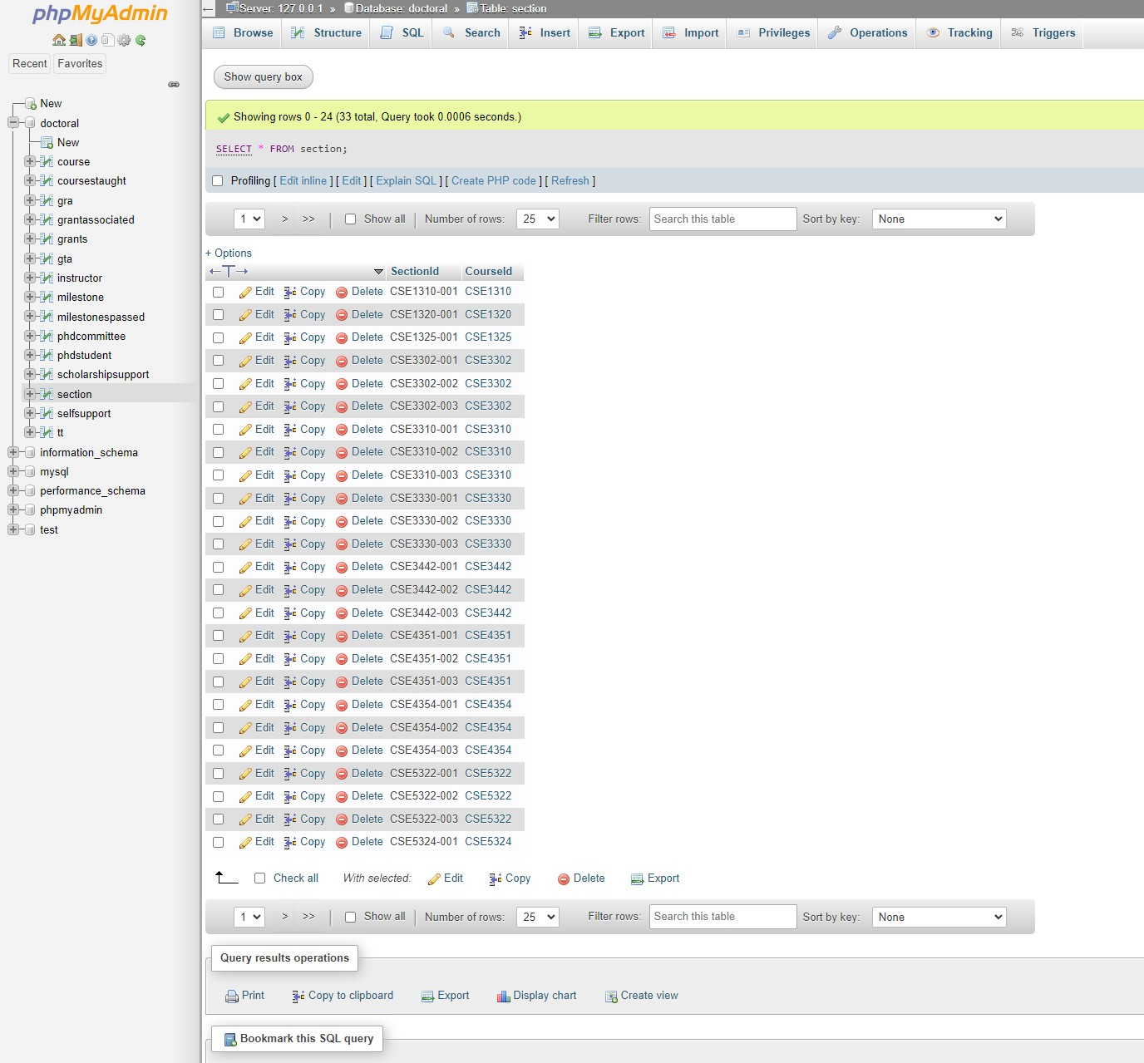

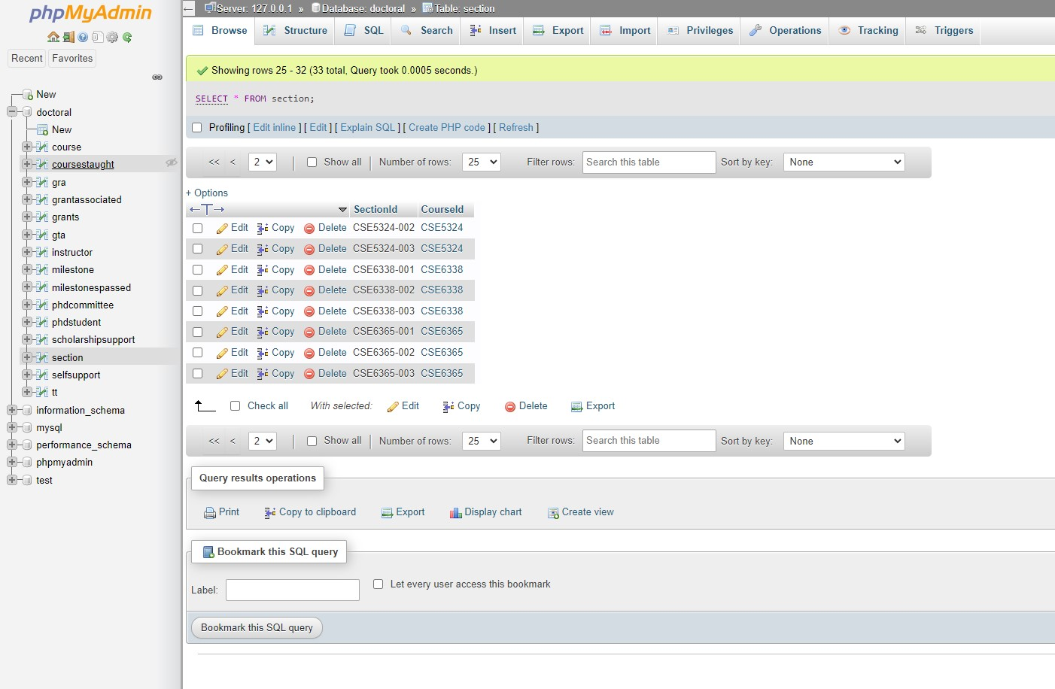

10. COURSESTAUGHT

Code:

CREATE TABLE COURSESTAUGHT

(CourseId CHAR(7) NOT NULL,

InstructorId CHAR(6) NOT NULL,

PRIMARY KEY(CourseId,InstructorId),

CONSTRAINT CTCOURSEFK

FOREIGN KEY (CourseId) REFERENCES COURSE(CourseId)

ON DELETE CASCADE ON UPDATE CASCADE,

CONSTRAINT CTINSTFK

FOREIGN KEY (InstructorId) REFERENCES INSTRUCTOR (InstructorId)

ON DELETE CASCADE ON UPDATE CASCADE);

Code Executed:

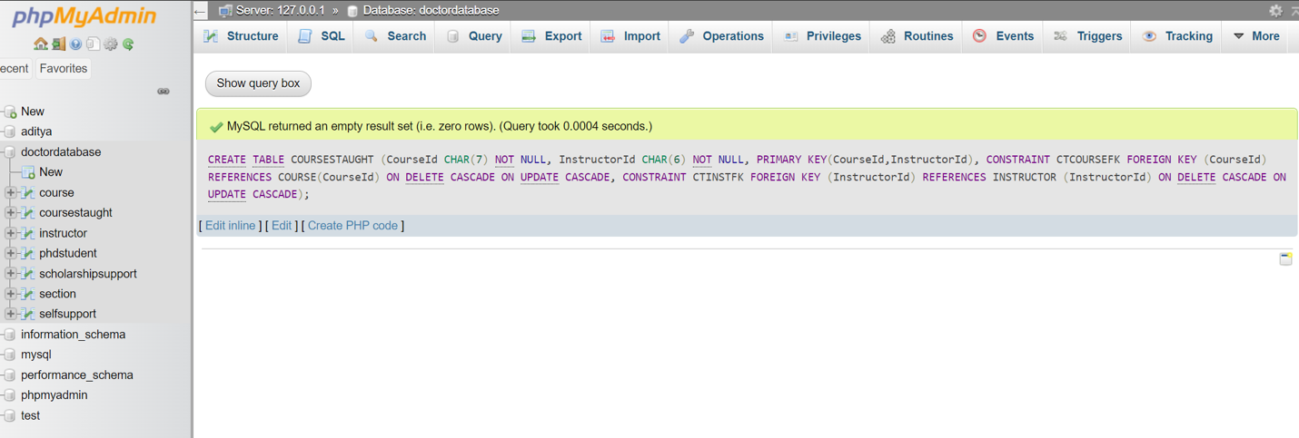

Datasets Uploaded:

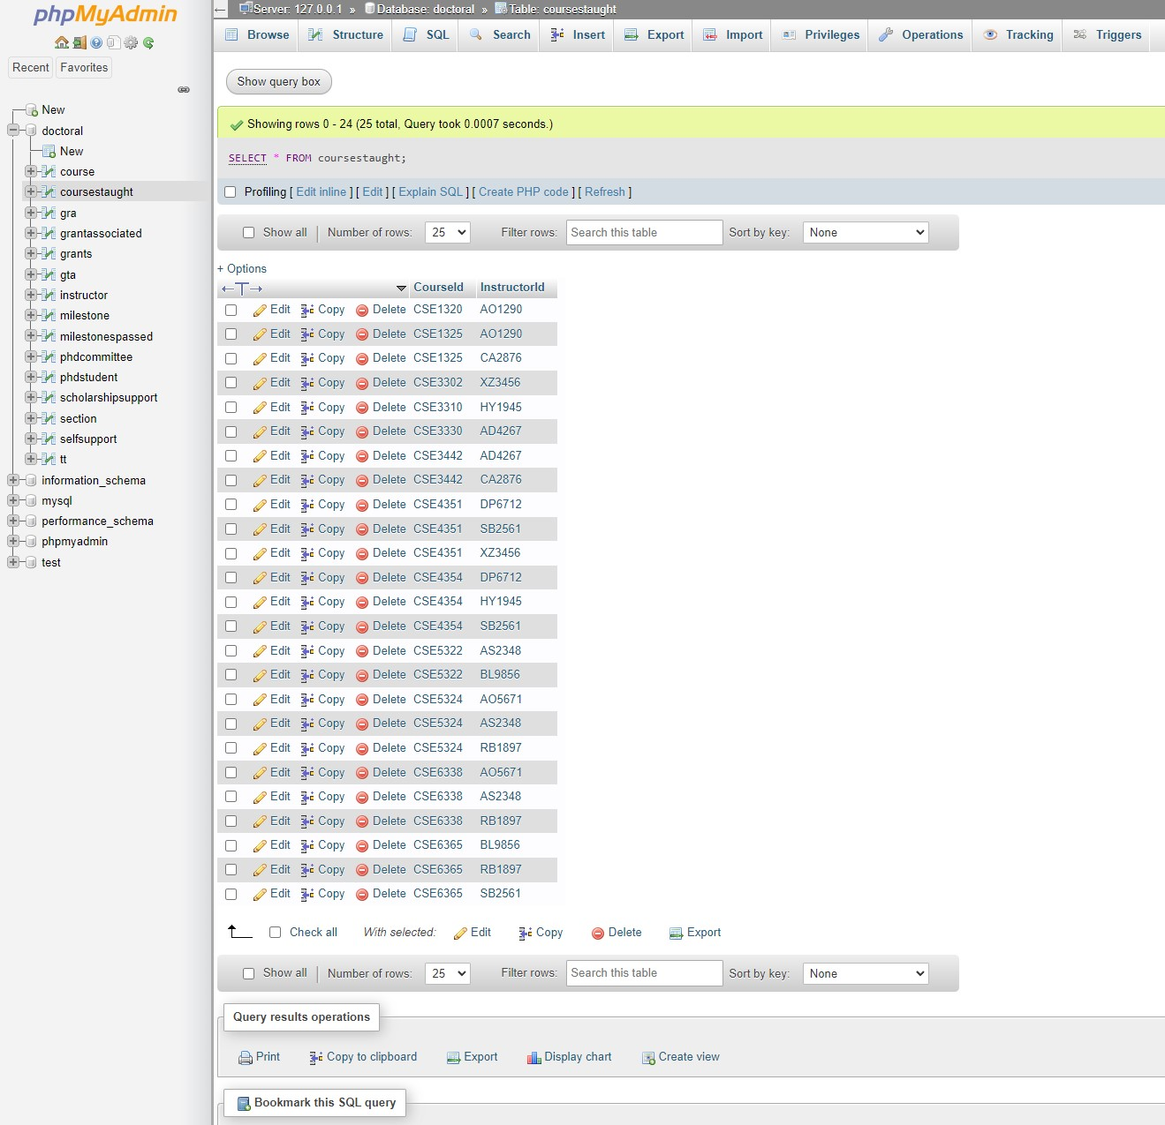

11. MILESTONE

Code:

CREATE TABLE MILESTONE

(MId CHAR(2) NOT NULL,

MName VARCHAR(25) NOT NULL,

PRIMARY KEY (MId)

UNIQUE (MName));

Code Executed: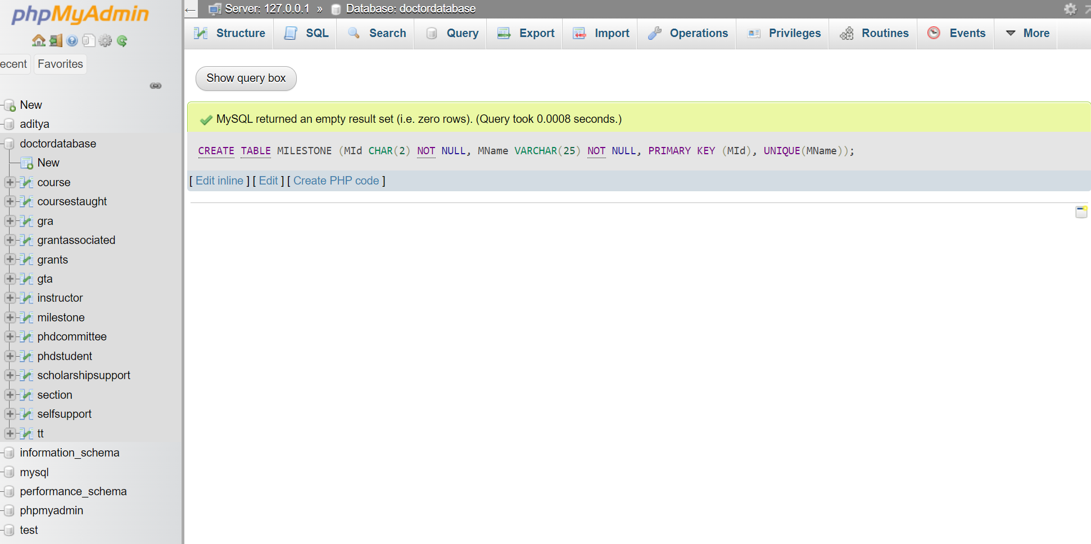

Dataset Uploaded

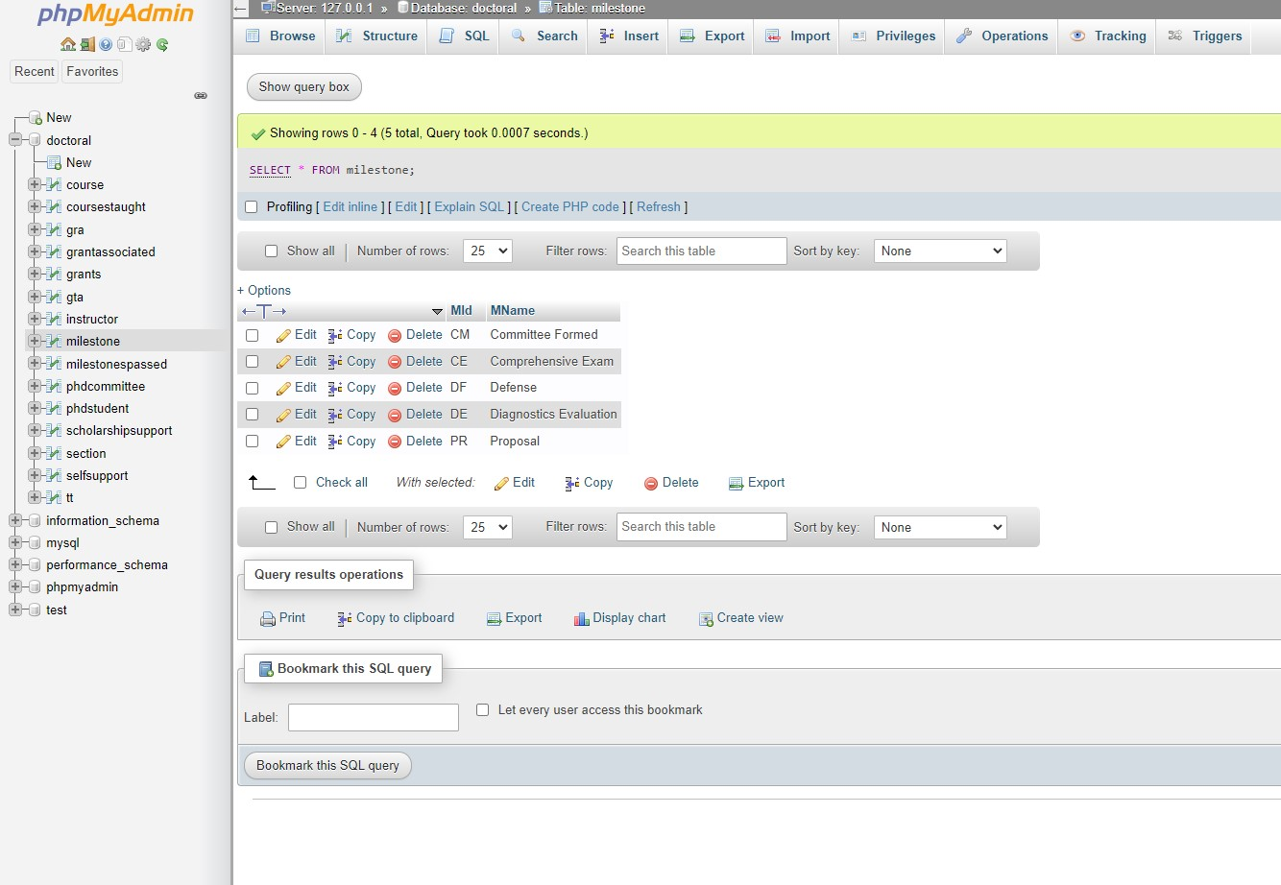

12. MILESTONESPASSED

Code:

CREATE TABLE MILESTONESPASSED

(StudentId CHAR(6) NOT NULL,

MId CHAR(2) NOT NULL,

PassDate DATE,

PRIMARY KEY (StudentId, MId),

CONSTRAINT MPPHDSTFK

FOREIGN KEY (StudentId) REFERENCES PHDSTUDENT (StudentId)

ON DELETE CASCADE ON UPDATE CASCADE,

CONSTRAINT MPMSFK

FOREIGN KEY (MId) REFERENCES MILESTONE (MId)

ON DELETE CASCADE ON UPDATE CASCADE);

Code Executed:

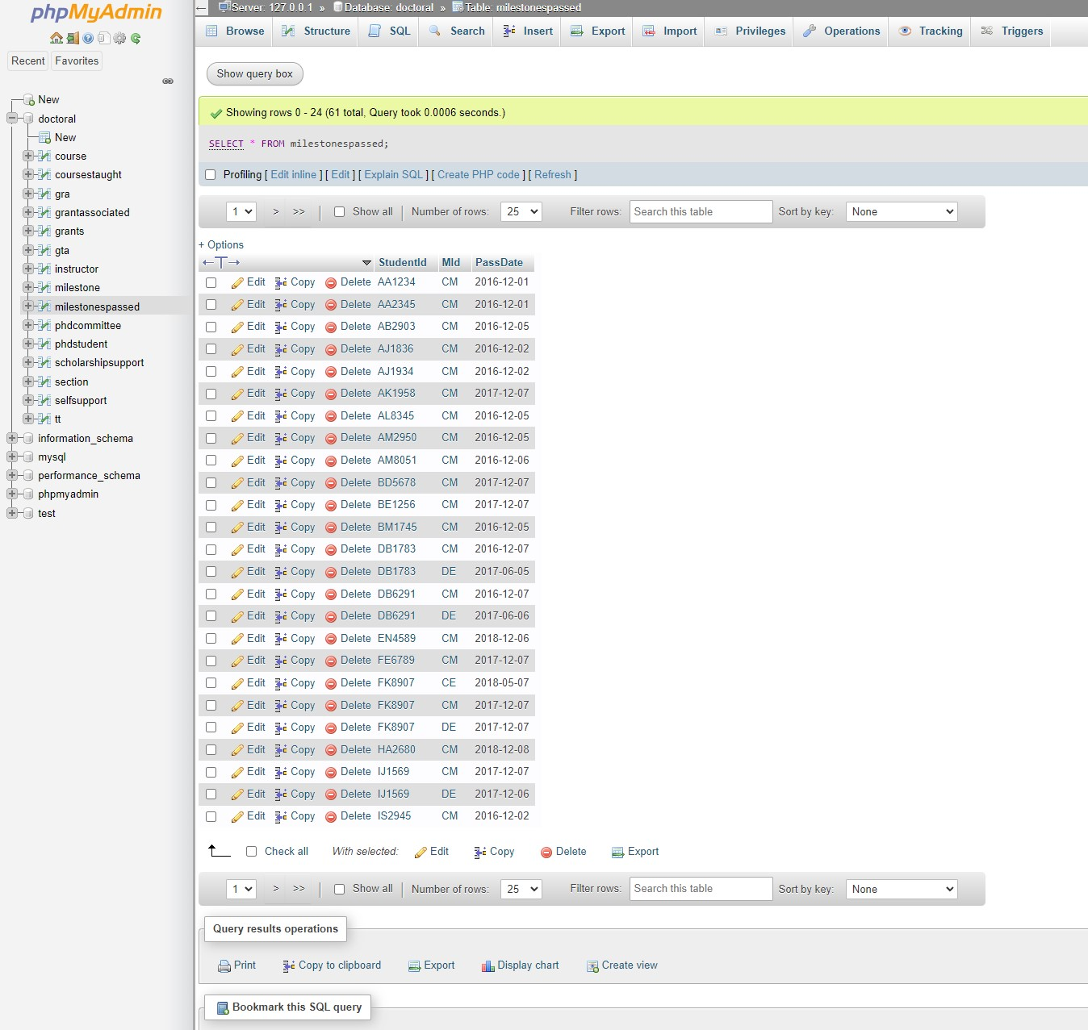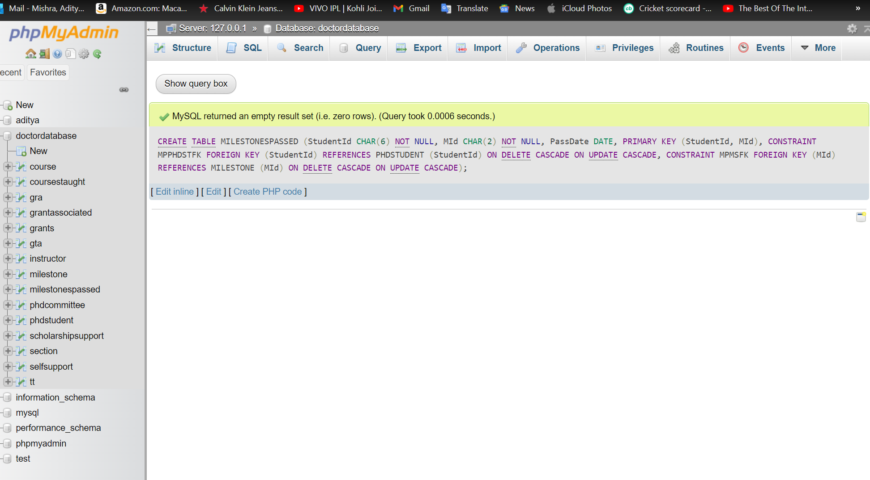

Datasets Uploaded:

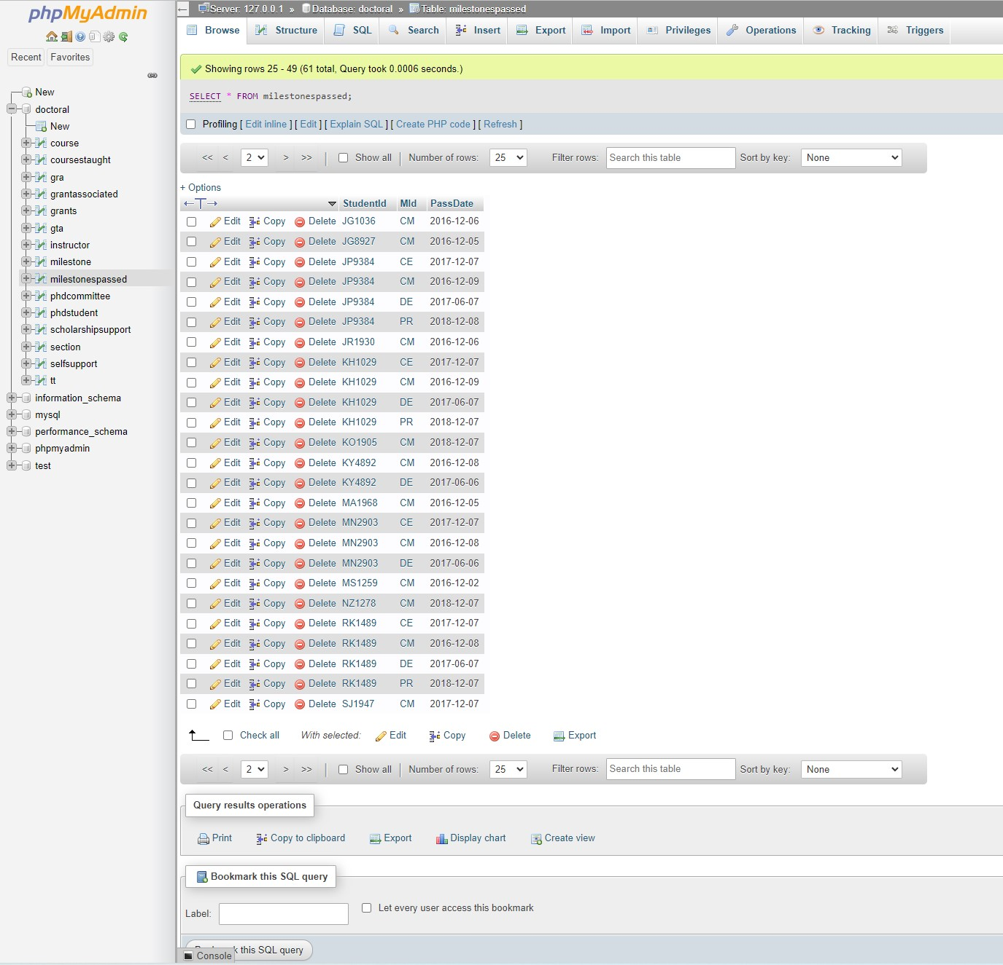

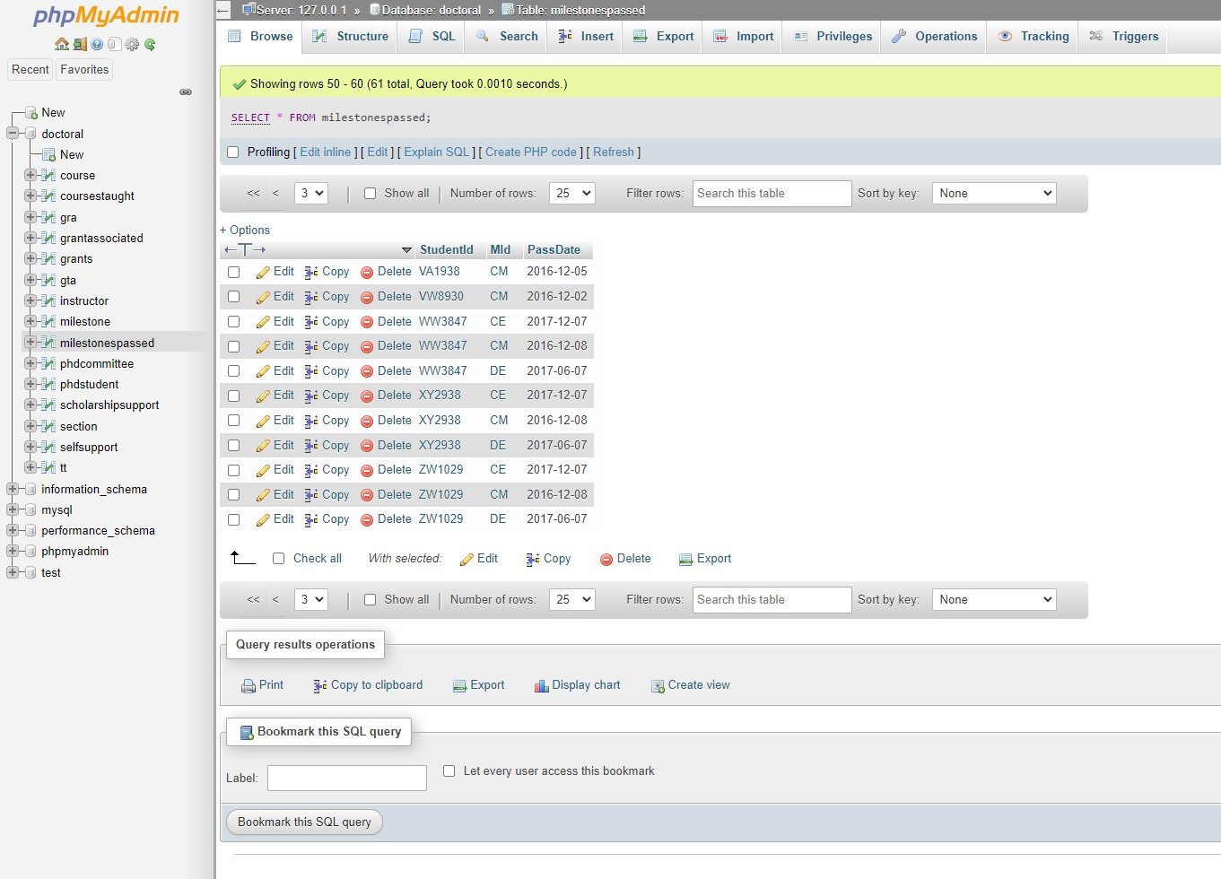

13. GRANTS

Code:

CREATE TABLE GRANTS

(AccountNo CHAR(4) NOT NULL,

Type VARCHAR(20) NOT NULL,

GrantTitle VARCHAR(35) NOT NULL,

Source VARCHAR(40) NOT NULL,

StDate DATE NOT NULL,

EndDate DATE NOT NULL,

StAmount DECIMAL(10,2) NOT NULL,

CurrBalance DECIMAL(10,2) NOT NULL,

PRIMARY KEY (AccountNo));

Code Executed:

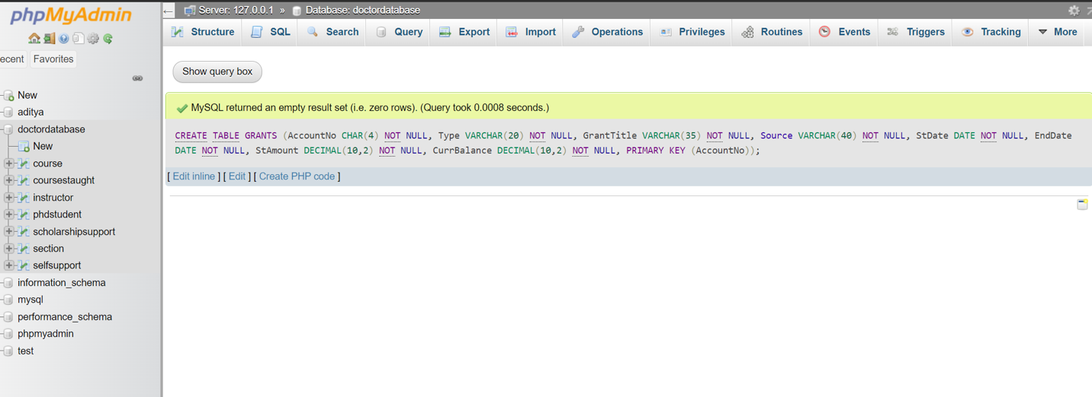

Datasets Uploaded:

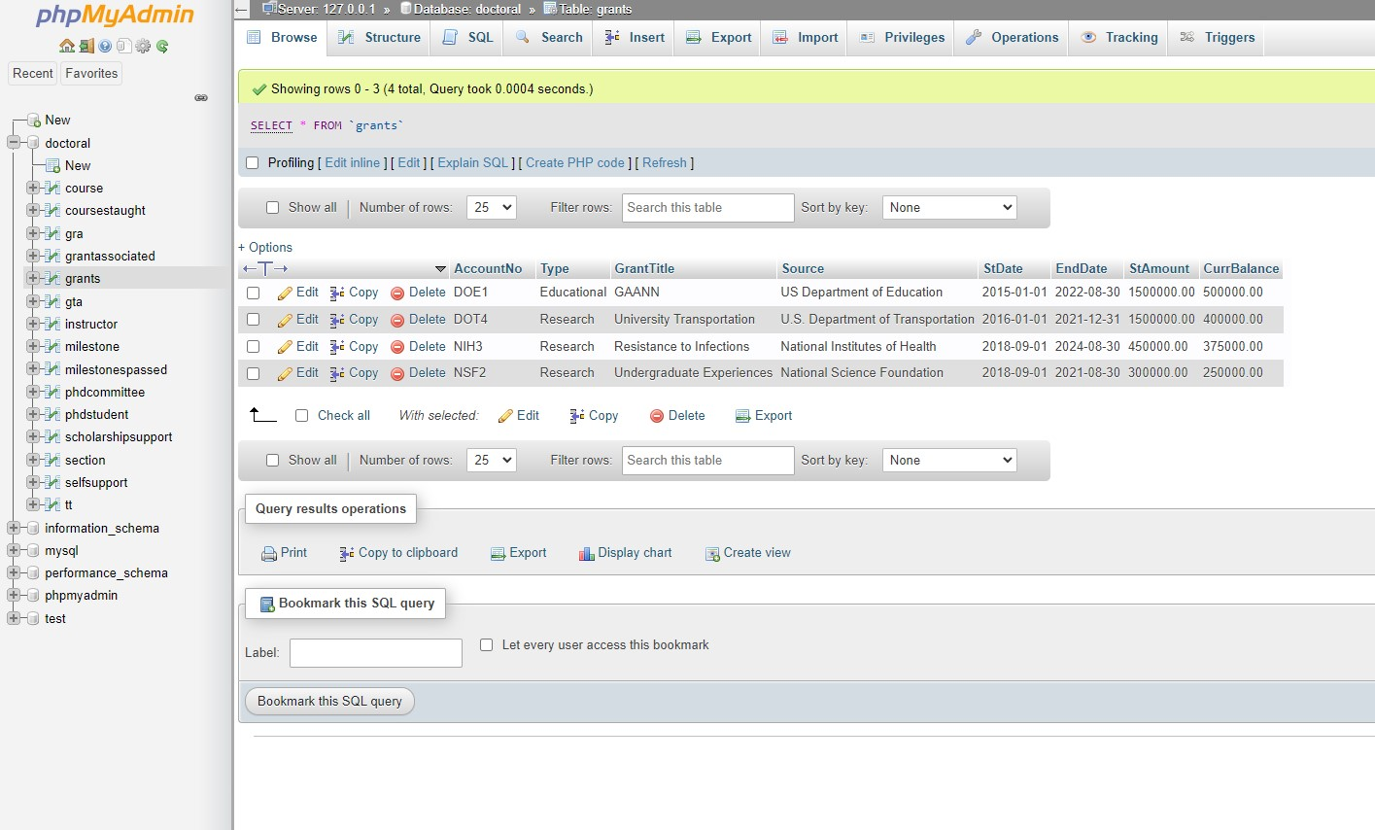

14. GRANTSASSOCIATED

Code:

CREATE TABLE GRANTASSOCIATED

(AccountNo CHAR(4) NOT NULL,

InstructorId CHAR(6) NOT NULL,

InstrType VARCHAR(4) NOT NULL,

PRIMARY KEY(AccountNo, InstructorId),

CONSTRAINT GAGRANTPK

FOREIGN KEY (AccountNo) REFERENCES GRANTS (AccountNo)

ON DELETE CASCADE ON UPDATE CASCADE,

CONSTRAINT GAINSTFK

FOREIGN KEY (InstructorId) REFERENCES INSTRUCTOR (InstructorId)

ON DELETE CASCADE ON UPDATE CASCADE);

Code Executed:

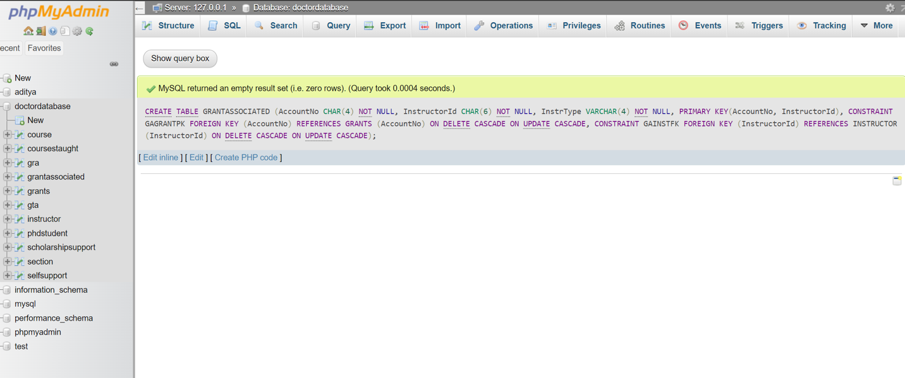

Datasets Uploaded

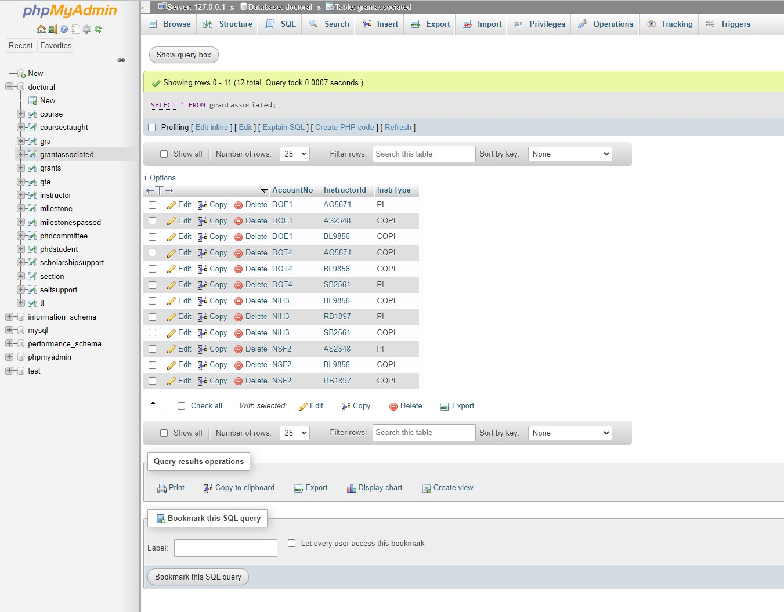

15. PHDCOMMITTEE

Code:

CREATE TABLE PHDCOMMITTEE

(StudentId CHAR(6) NOT NULL,

InstructorId CHAR(6) NOT NULL,

PRIMARY KEY (StudentId, InstructorId),

CONSTRAINT PHDCOMMSTFK

FOREIGN KEY (StudentId) REFERENCES PHDSTUDENT (StudentId)

ON DELETE CASCADE ON UPDATE CASCADE,

CONSTRAINT PHDCOMMINSFK

FOREIGN KEY (InstructorId) REFERENCES INSTRUCTOR (InstructorId)

ON DELETE CASCADE ON UPDATE CASCADE);

Code Executed:

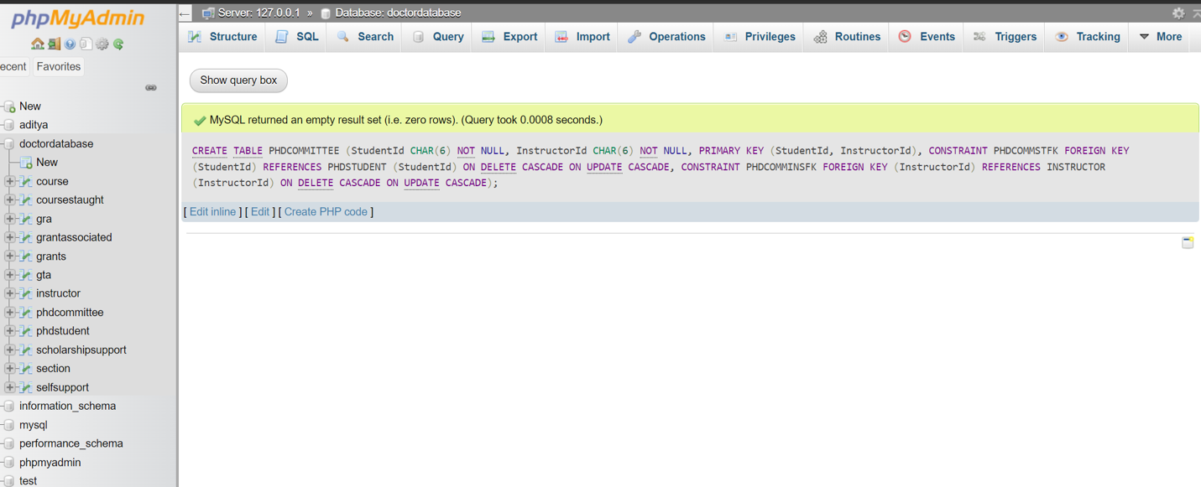

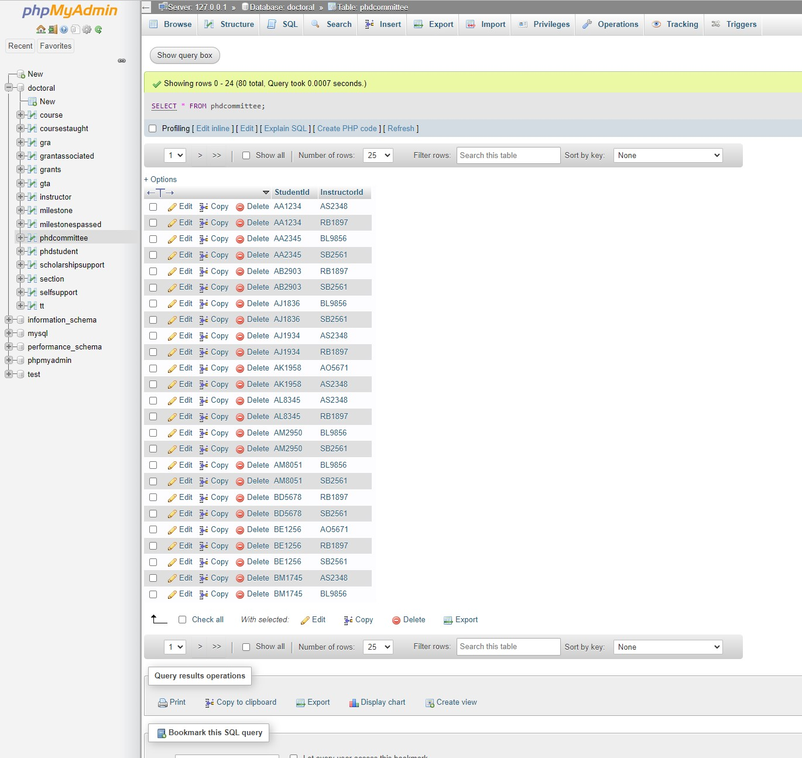

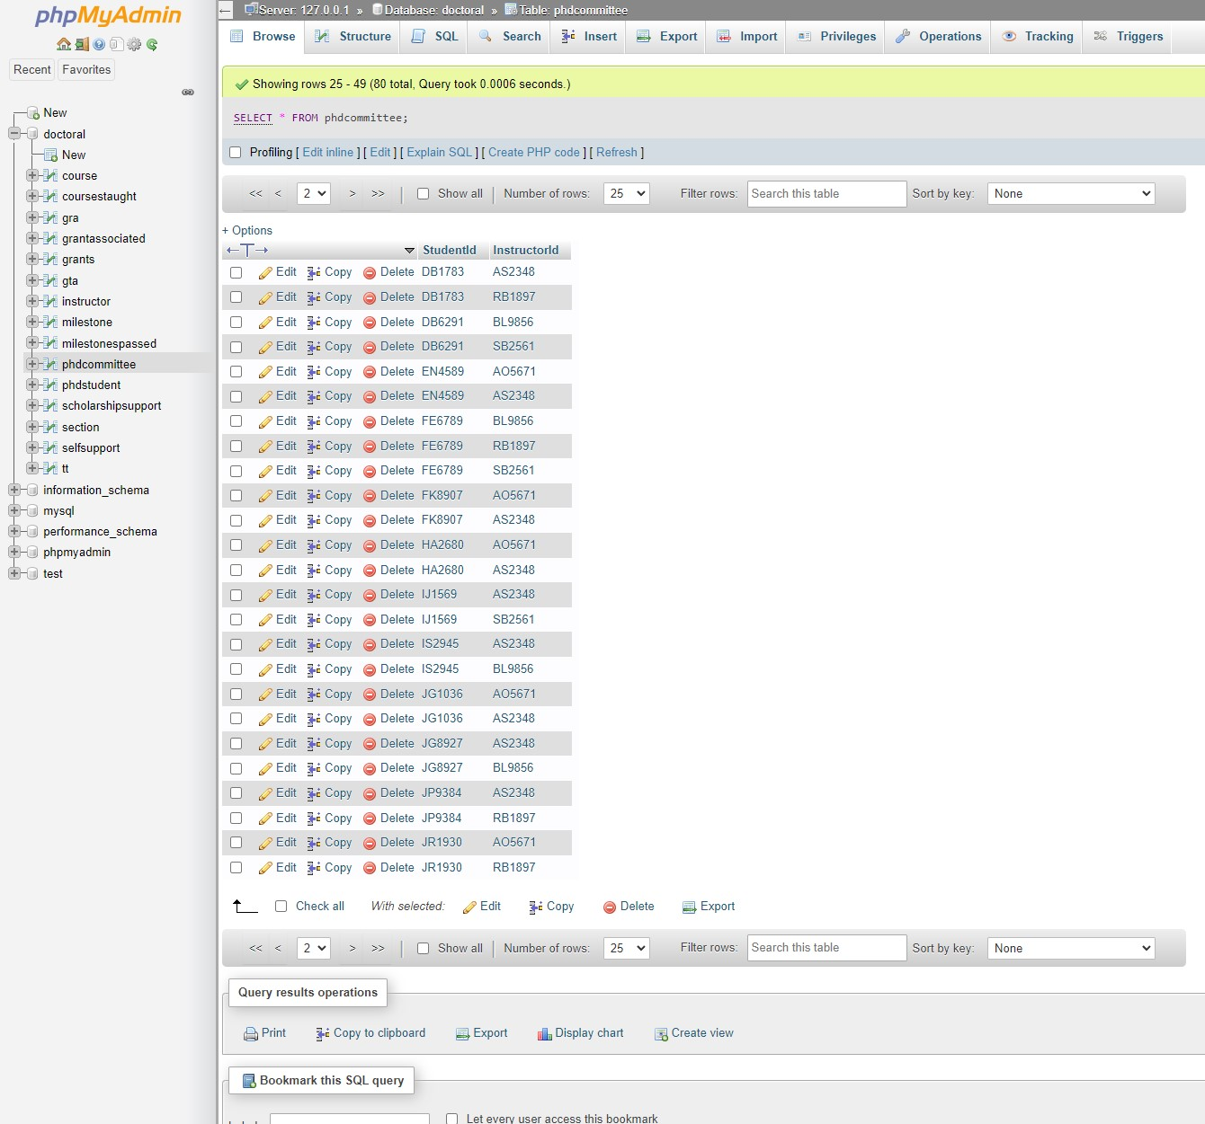

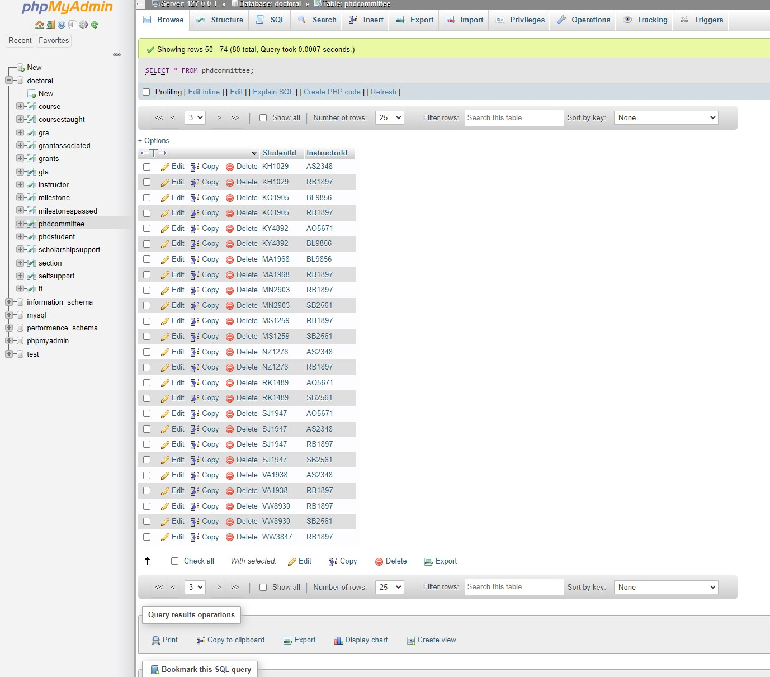

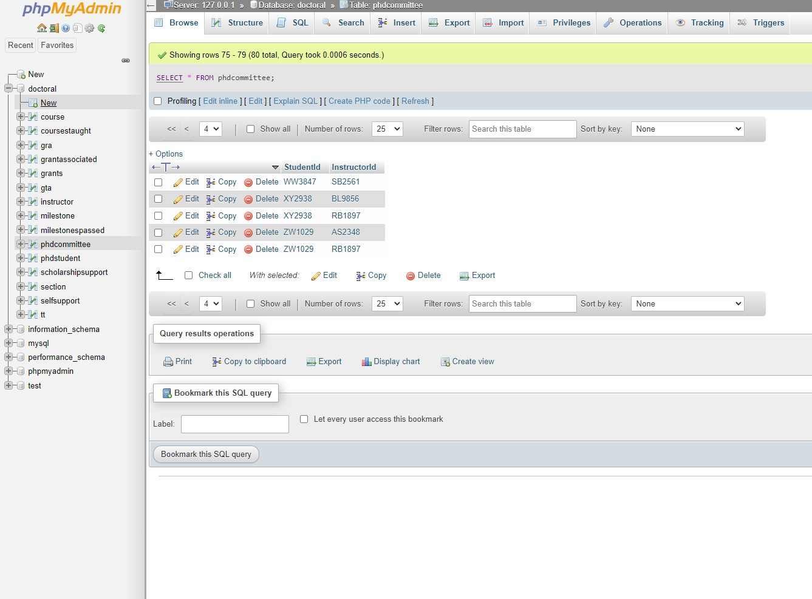

**Part 2 Queries and Views**

**The logs show we created PHDSTUDENT_PAY as view.**



1. **Views of PHDSTUDENT_PAY is shown below:**

**Code:**

CREATE VIEW PHDSTUDENT_PAY(SID,SFName,SLName,MontlyPay) AS

(SELECT DISTINCT p.StudentId,p.FName,p.LName,t.MontlyPay

FROM phdstudent p, gta t

WHERE p.StudentId=t.StudentId)

UNION

(SELECT DISTINCT p.StudentId, p.FName,p.LName, r.MonthlyPay

FROM phdstudent p, gra r

WHERE p.StudentId=r.StudentId)**;**

You can refer to the picture below which clearly shows that we have created.

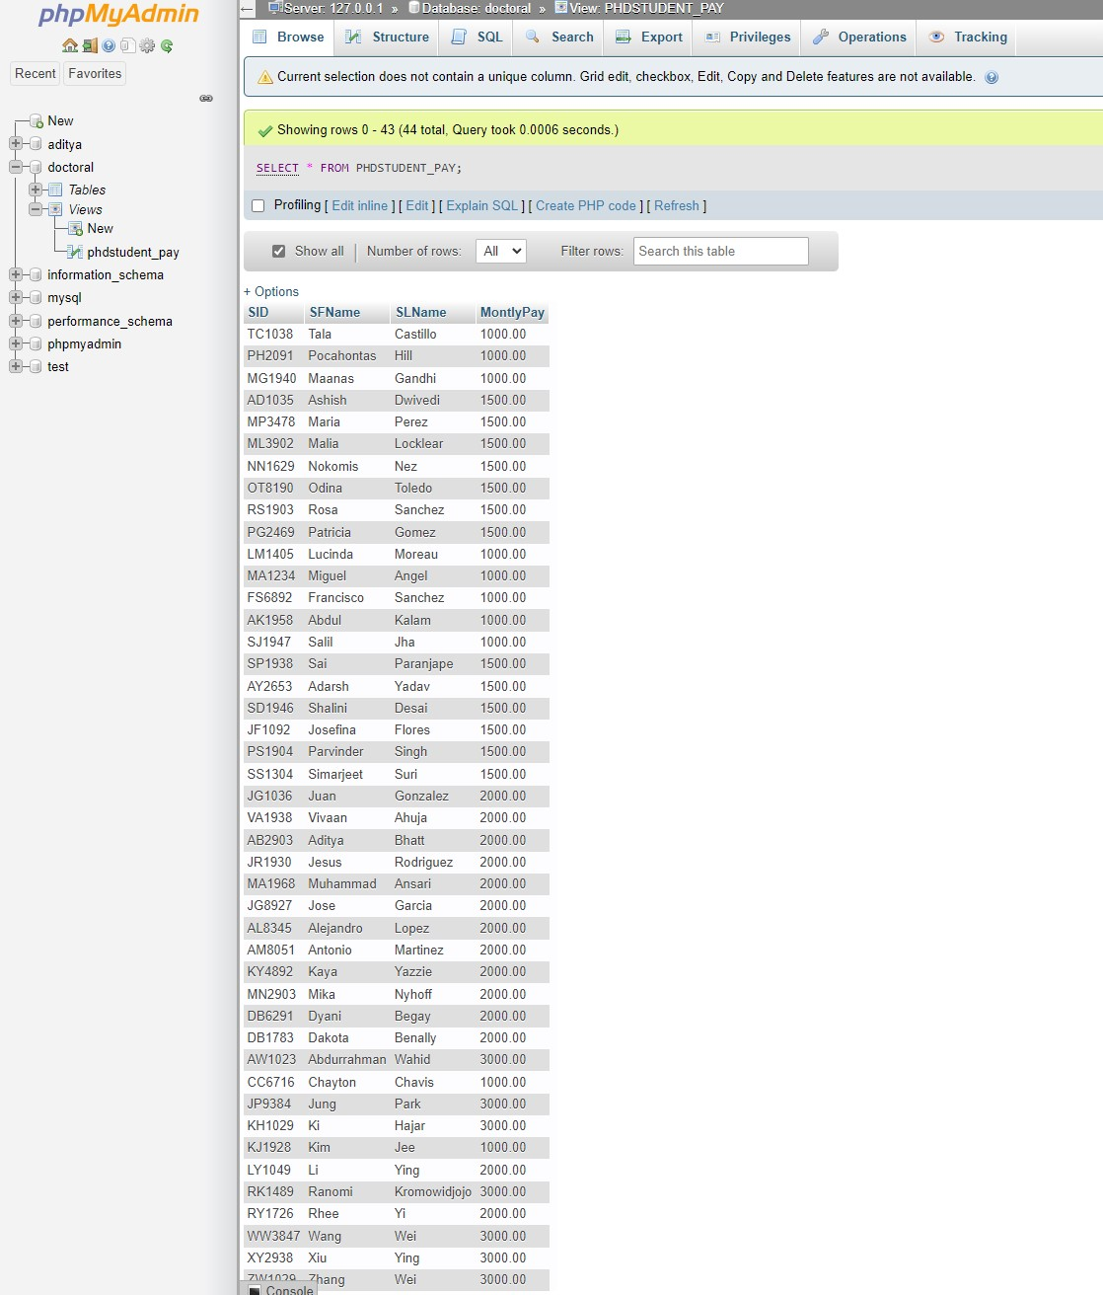

2A

Code of PHDSTUDENT_PAY in ASCENDING ORDER.

CREATE VIEW PHDSTUDENT_PAY(SID,SFName,SLName,MontlyPay) AS

(SELECT DISTINCT p.StudentId,p.FName,p.LName,t.MontlyPay

FROM phdstudent p, gta t

WHERE p.StudentId=t.StudentId)

UNION

(SELECT DISTINCT p.StudentId, p.FName,p.LName, r.MonthlyPay

FROM phdstudent p, gra r

WHERE p.StudentId=r.StudentId);

SELECT * FROM `phdstudent_pay` ORDER BY LName ASC

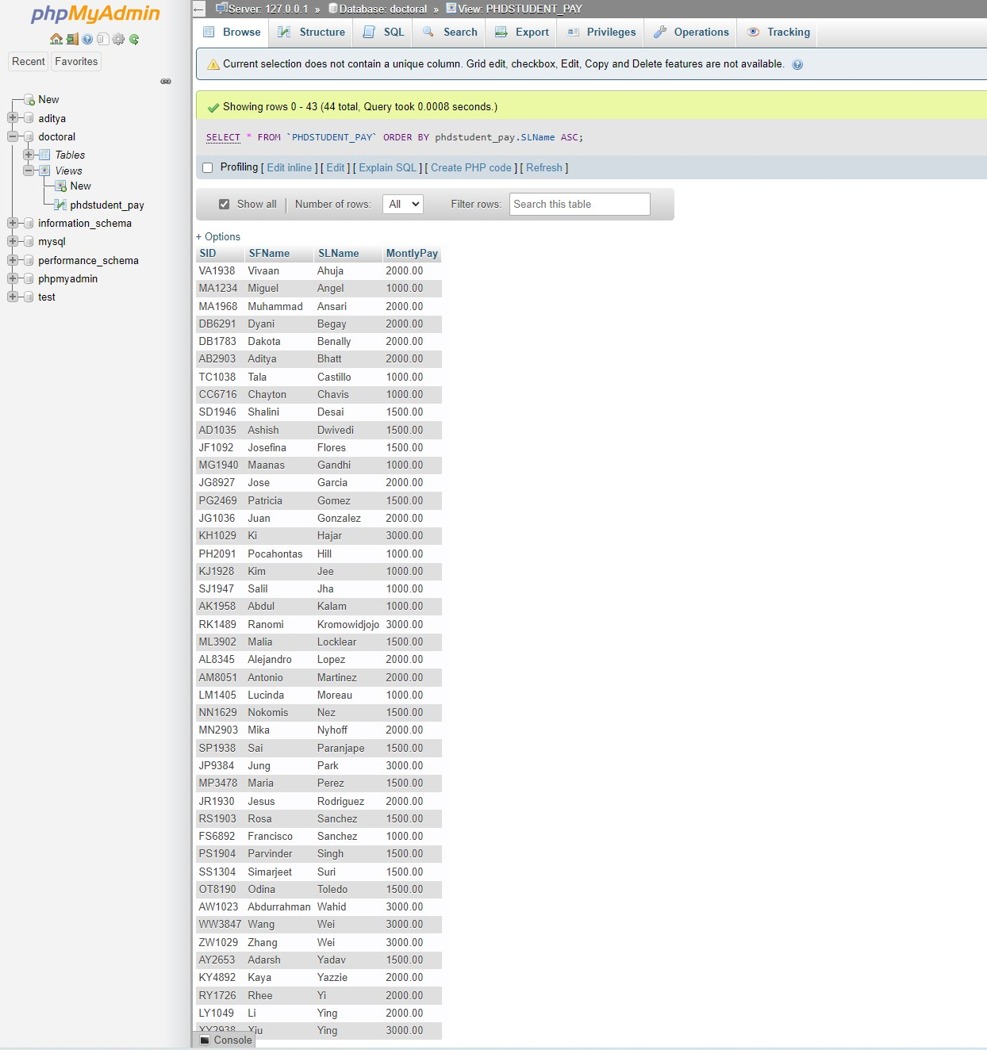

2B

**With professor’s first name and last name. This part is to show that the course belongs to the professor. Below is without professor’s name.**

Codes are shown inside the picture. Please refer to the picture.

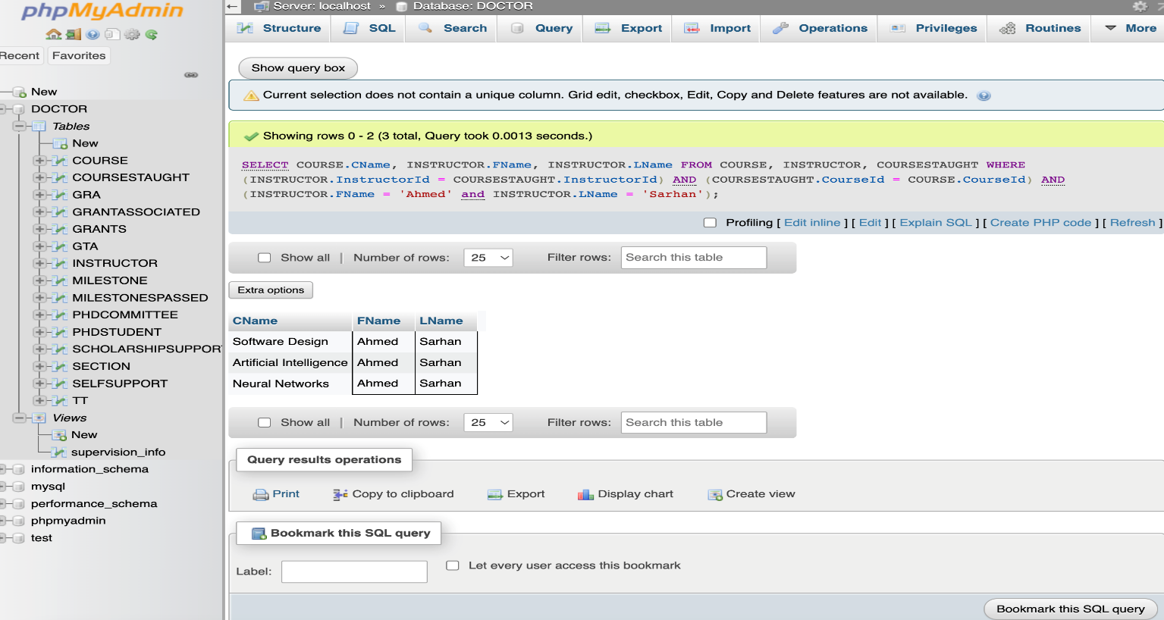

Without professor’s first name and last name.

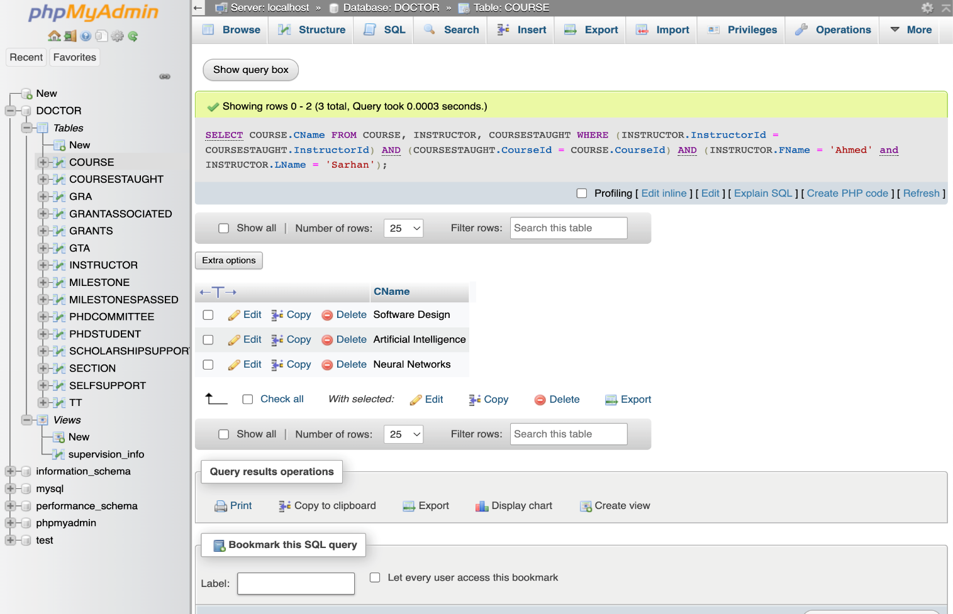

2C

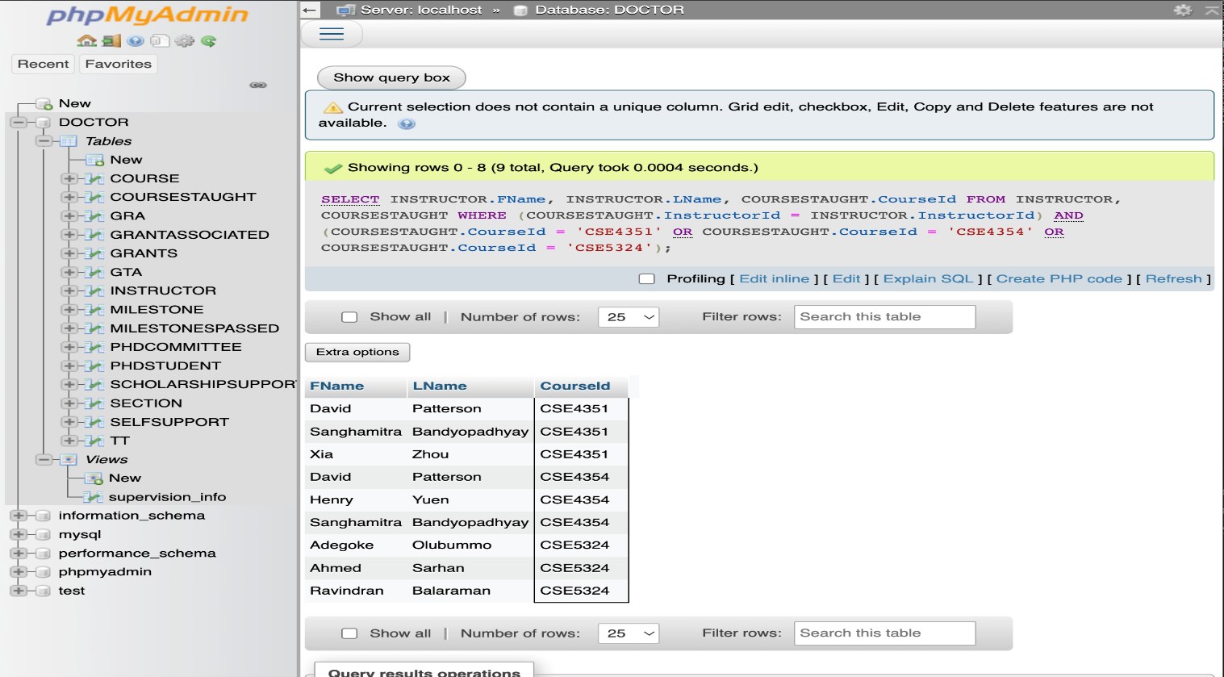

4.i

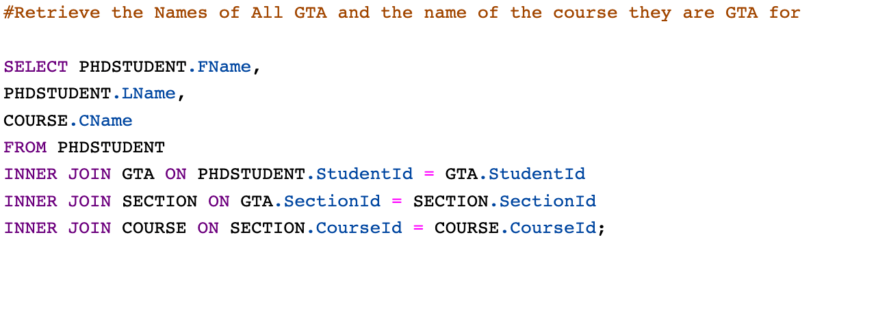

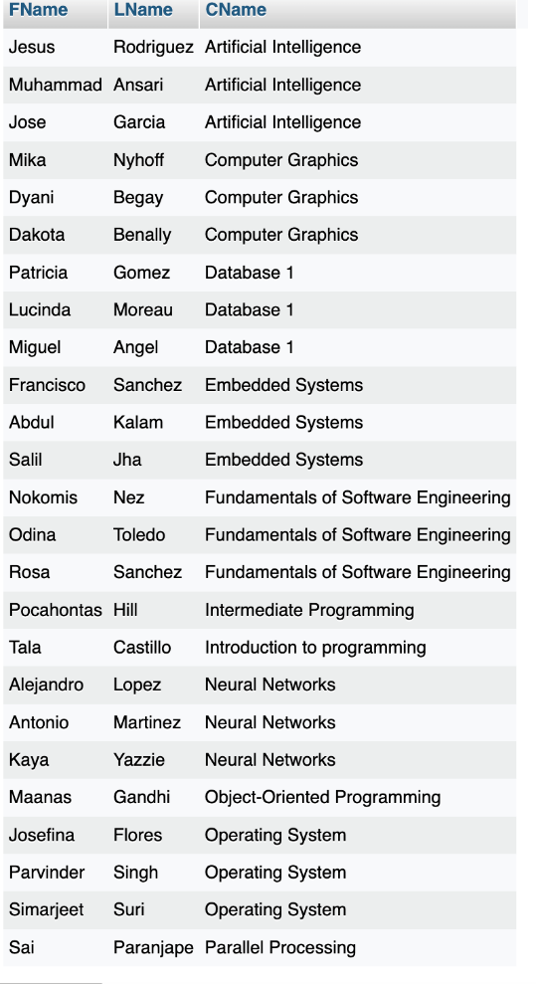

5ii

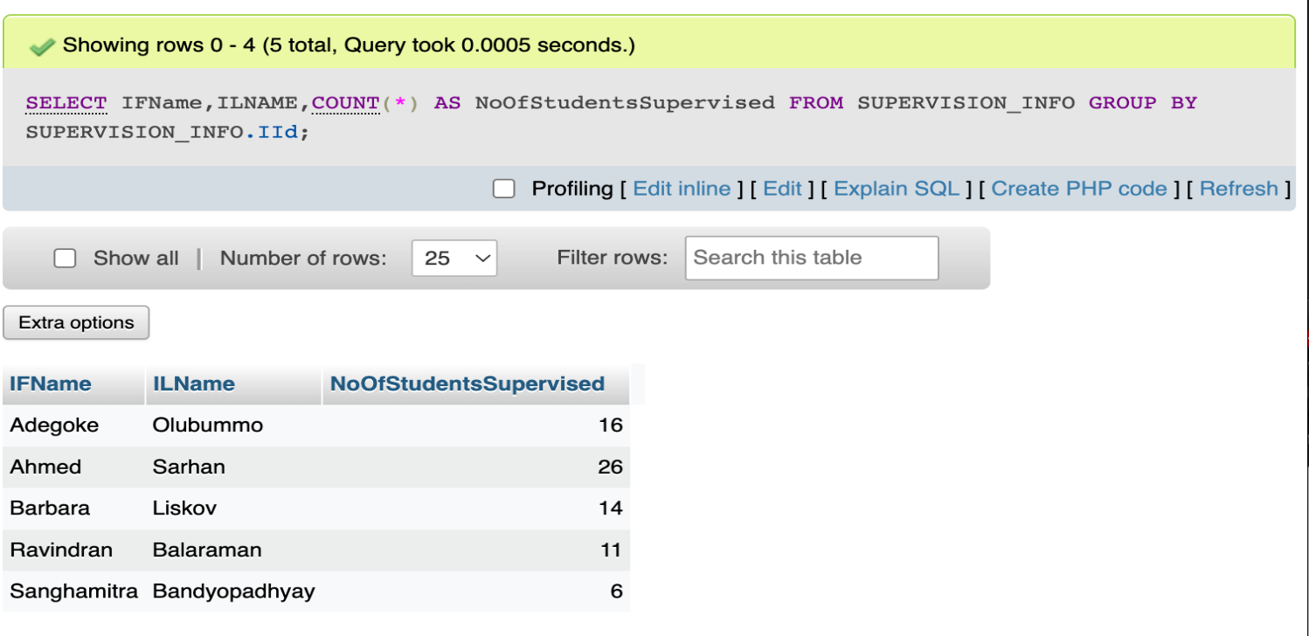

5iii

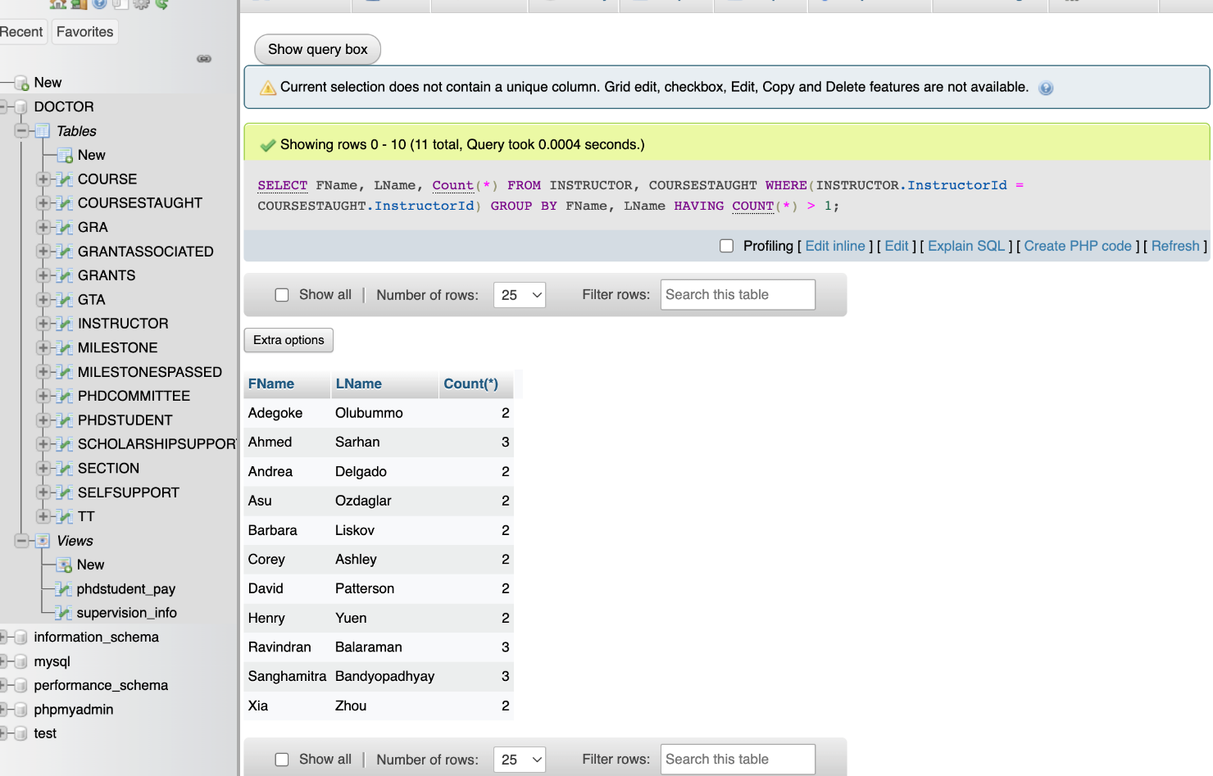

**5iv**

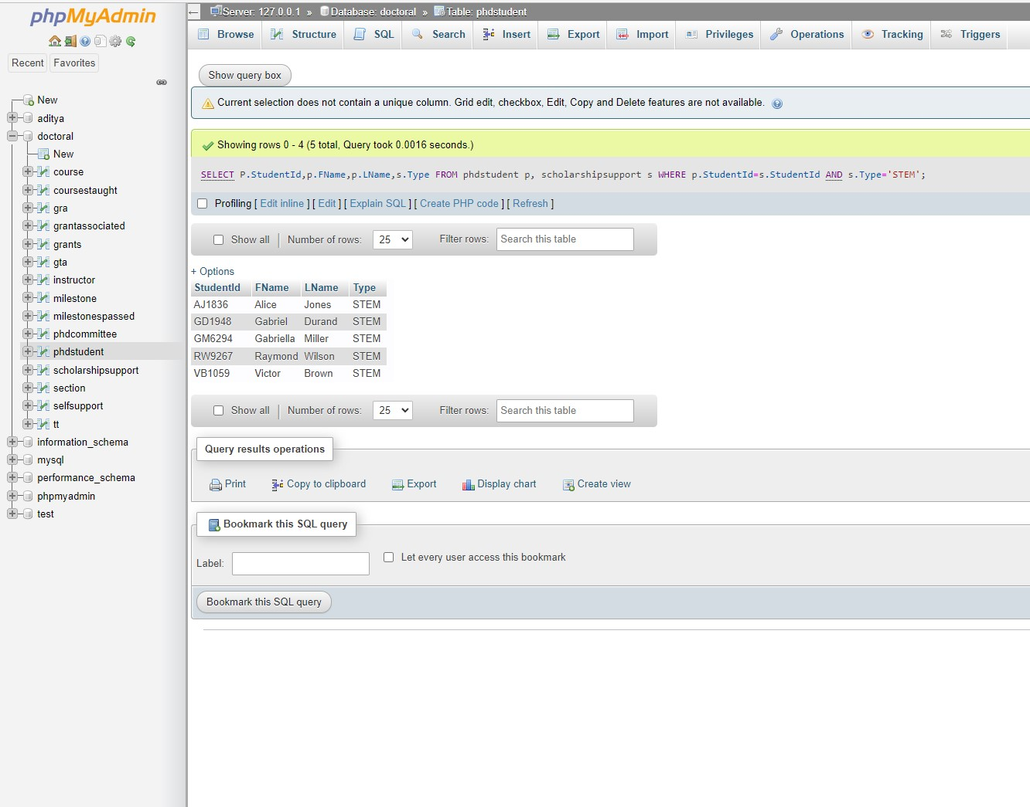

**5v**

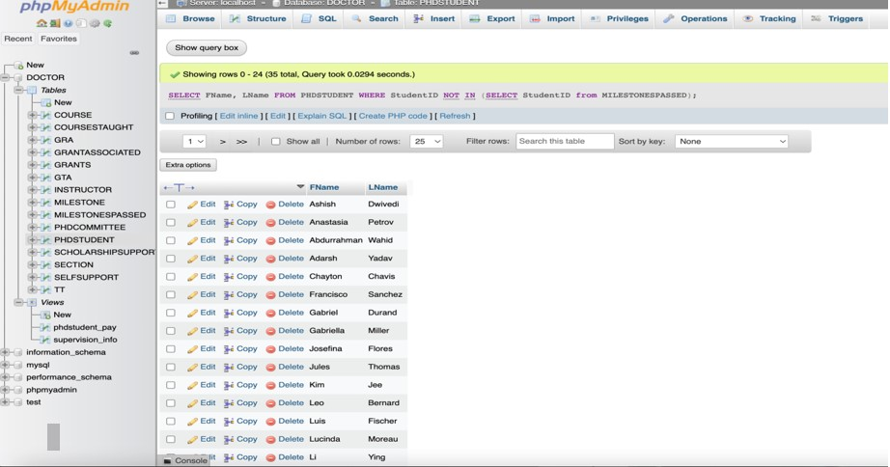

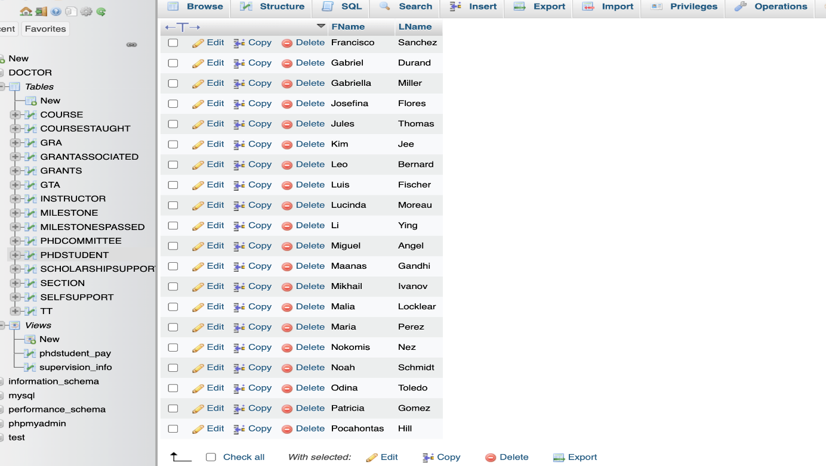

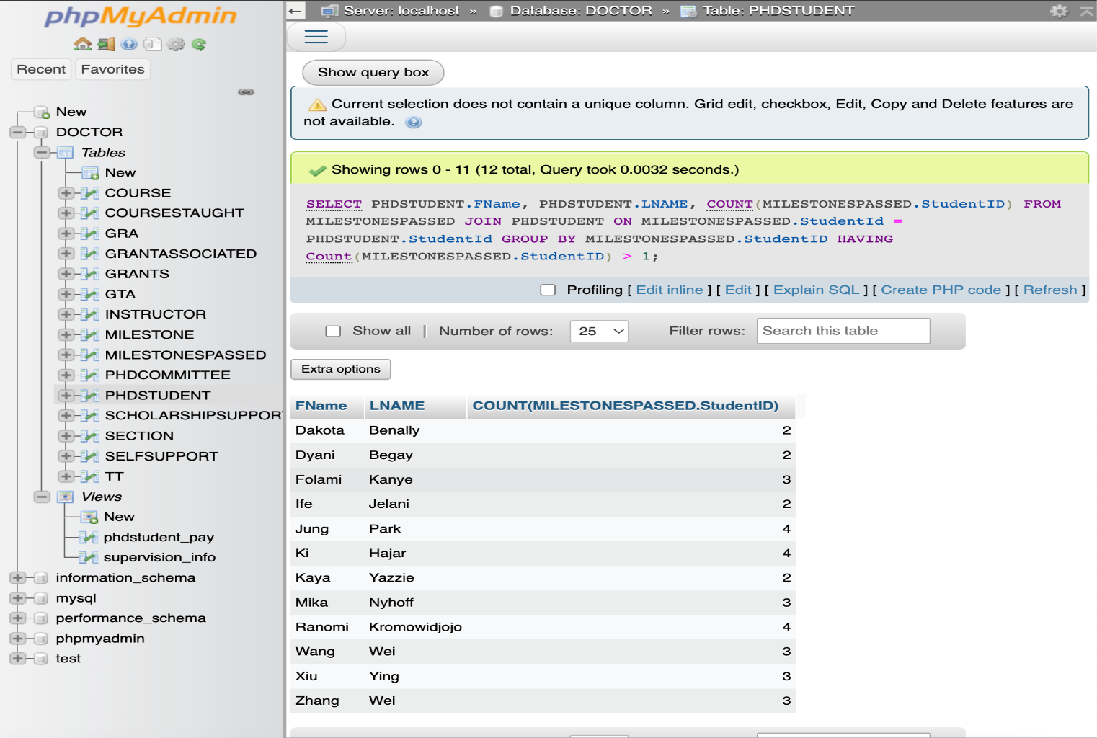**5vi**

**5vii**

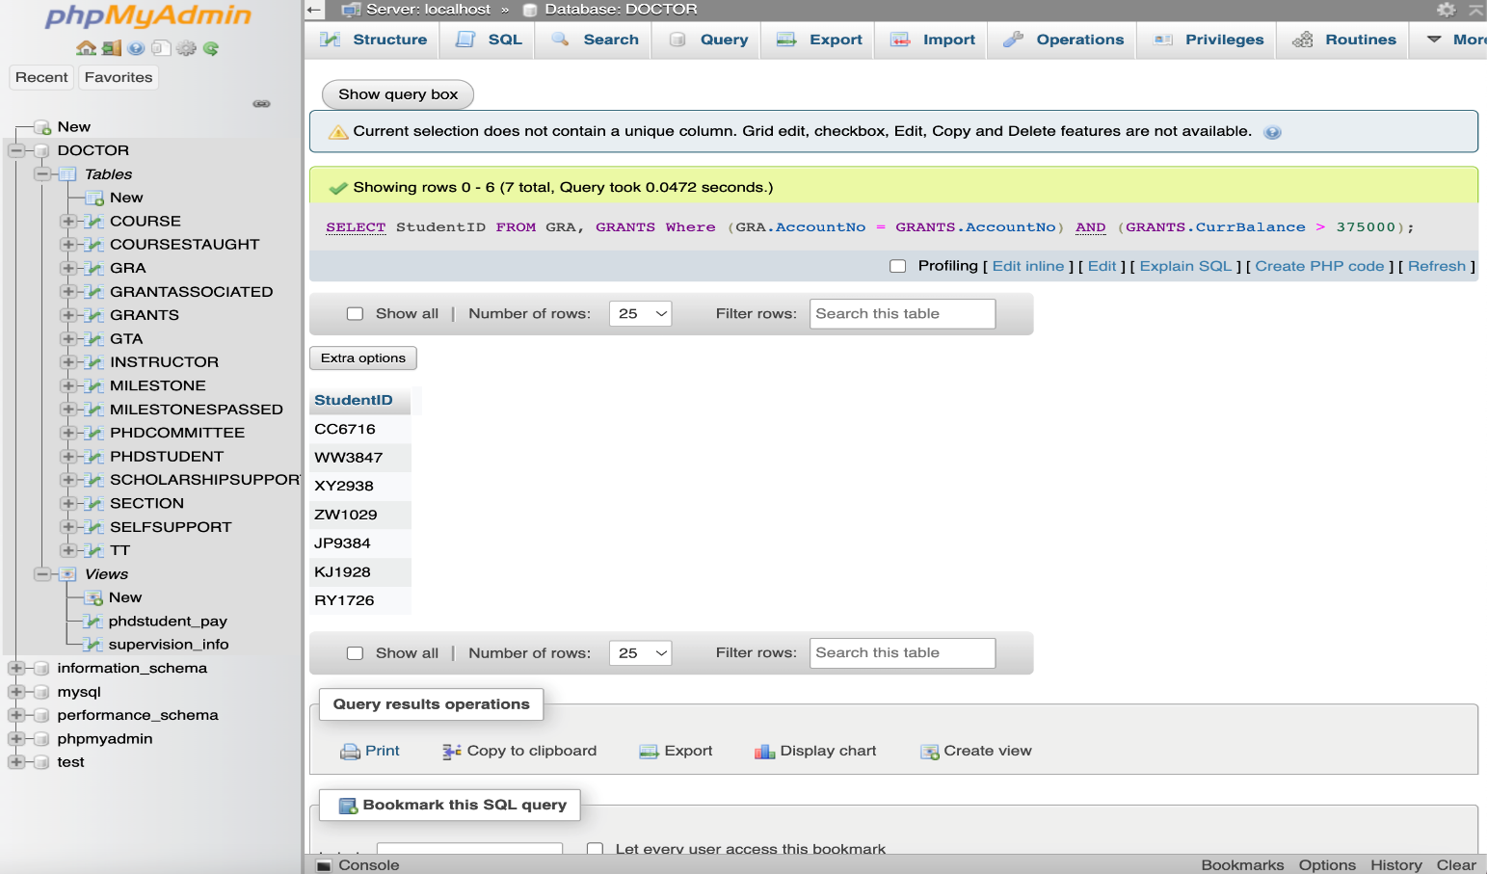

**5viii**

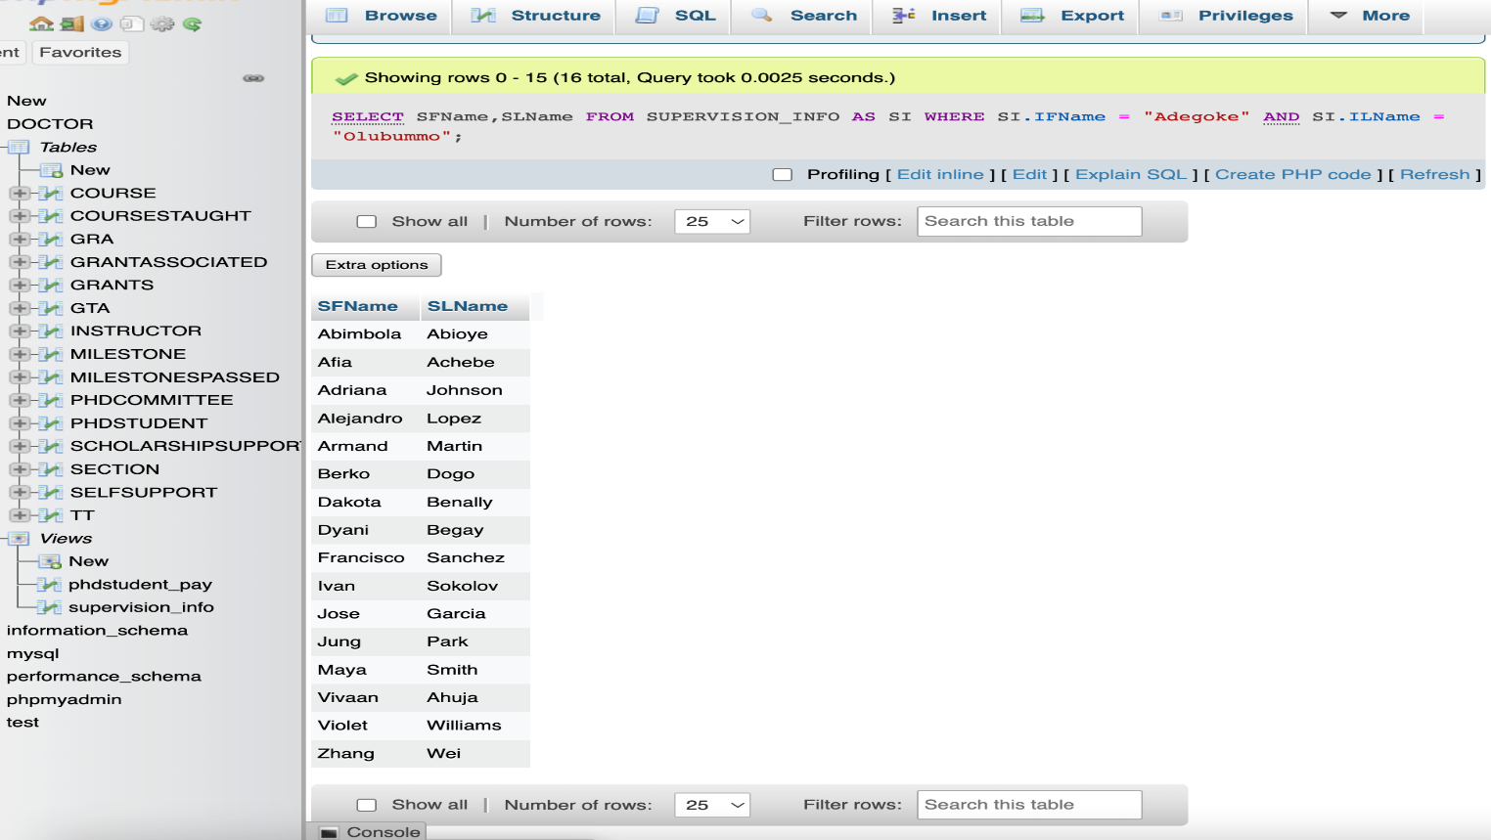

**5ix**

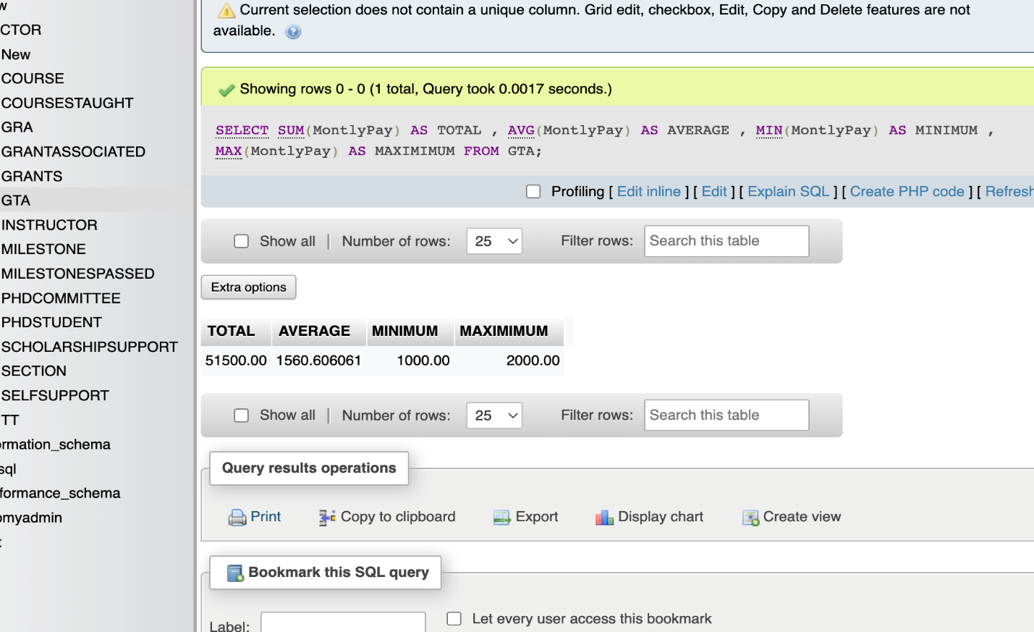

**5x**

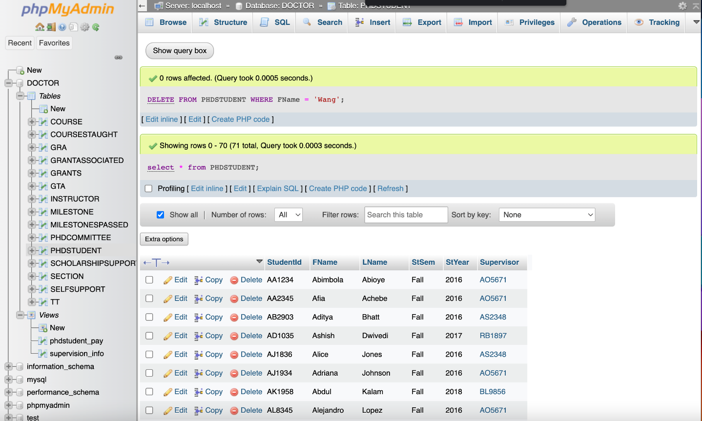

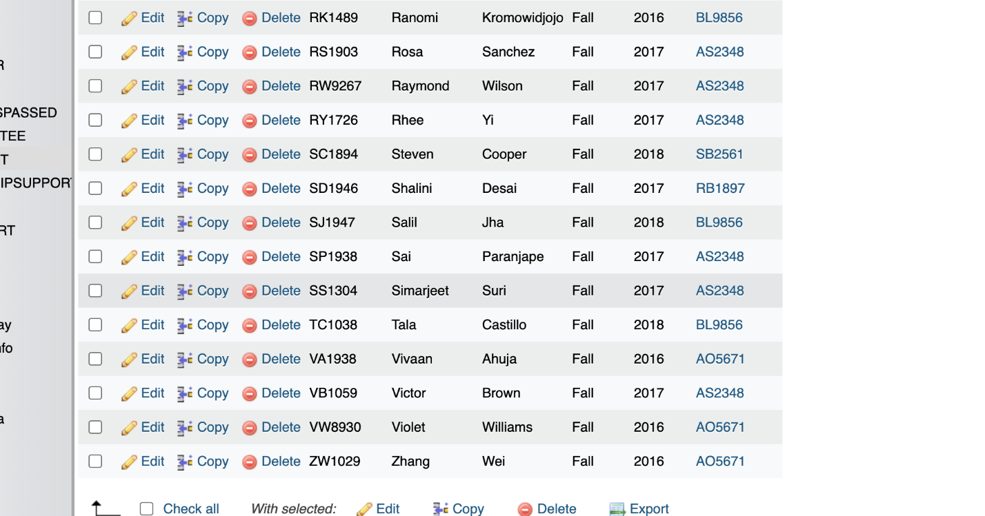

**5xi**

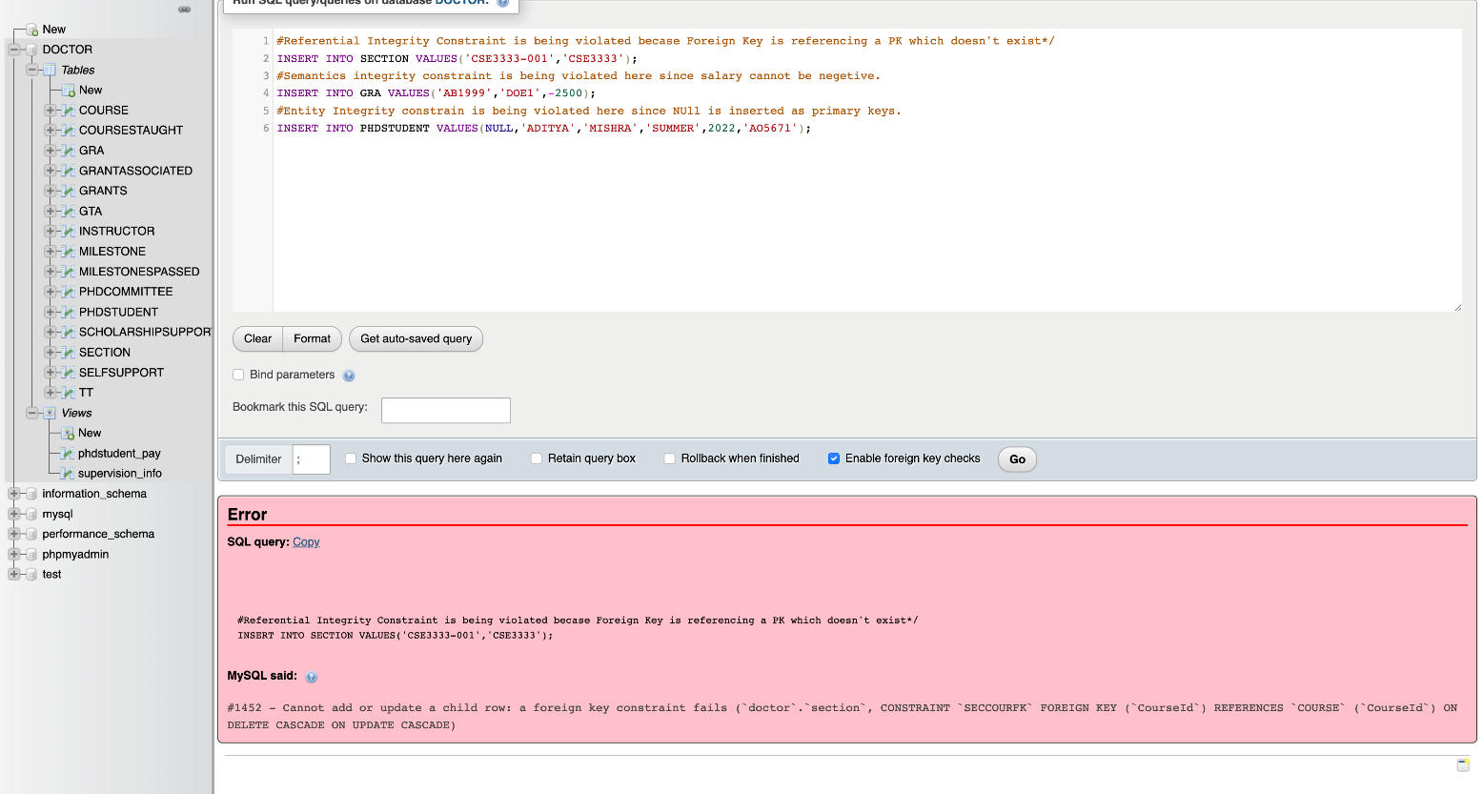

**5xii**

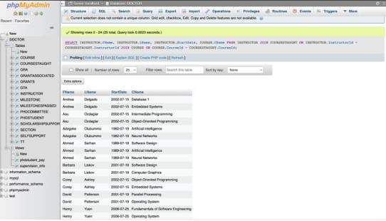

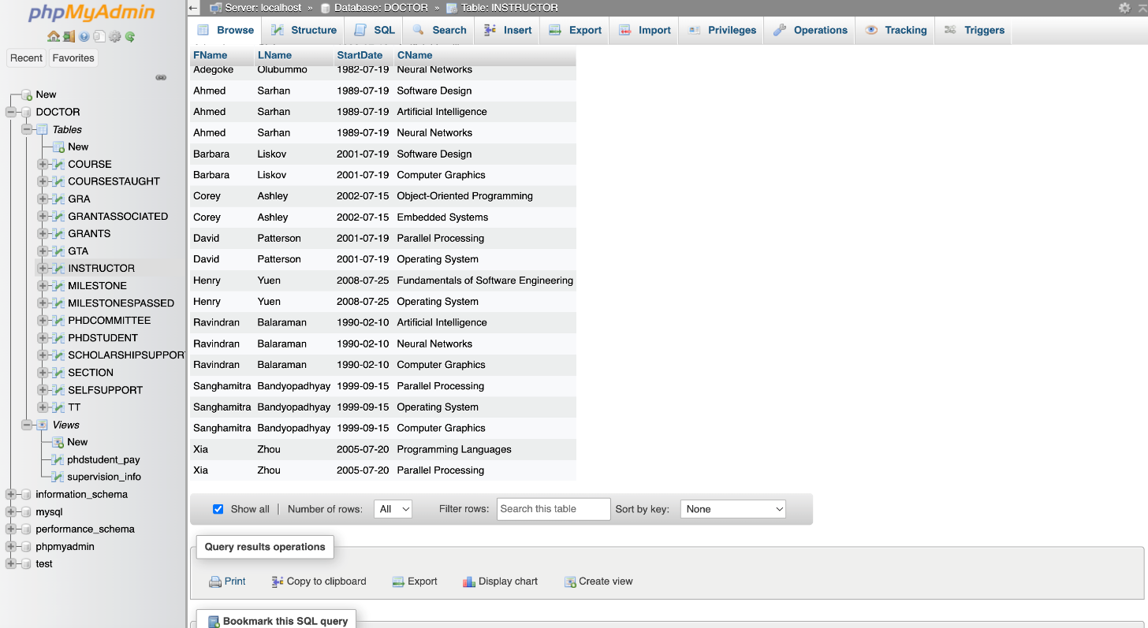

**5xiii**

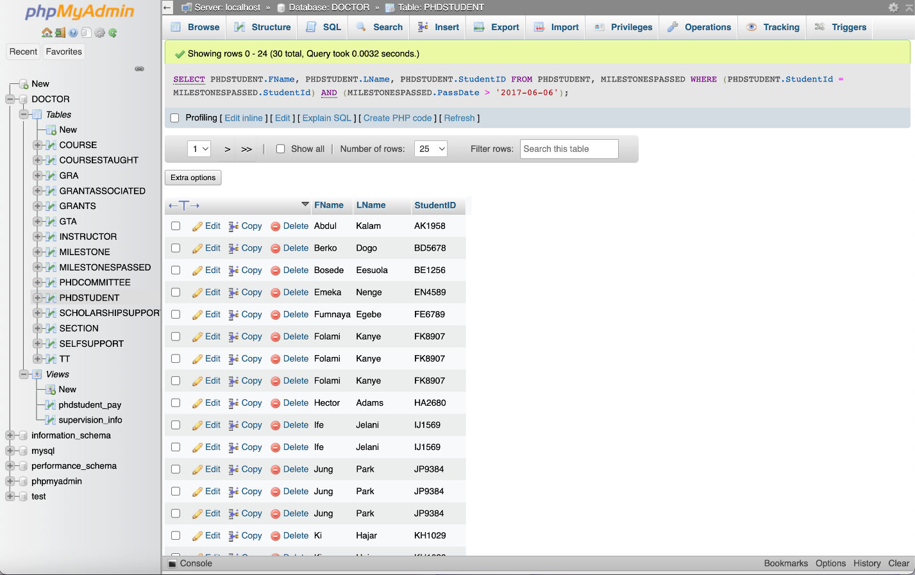

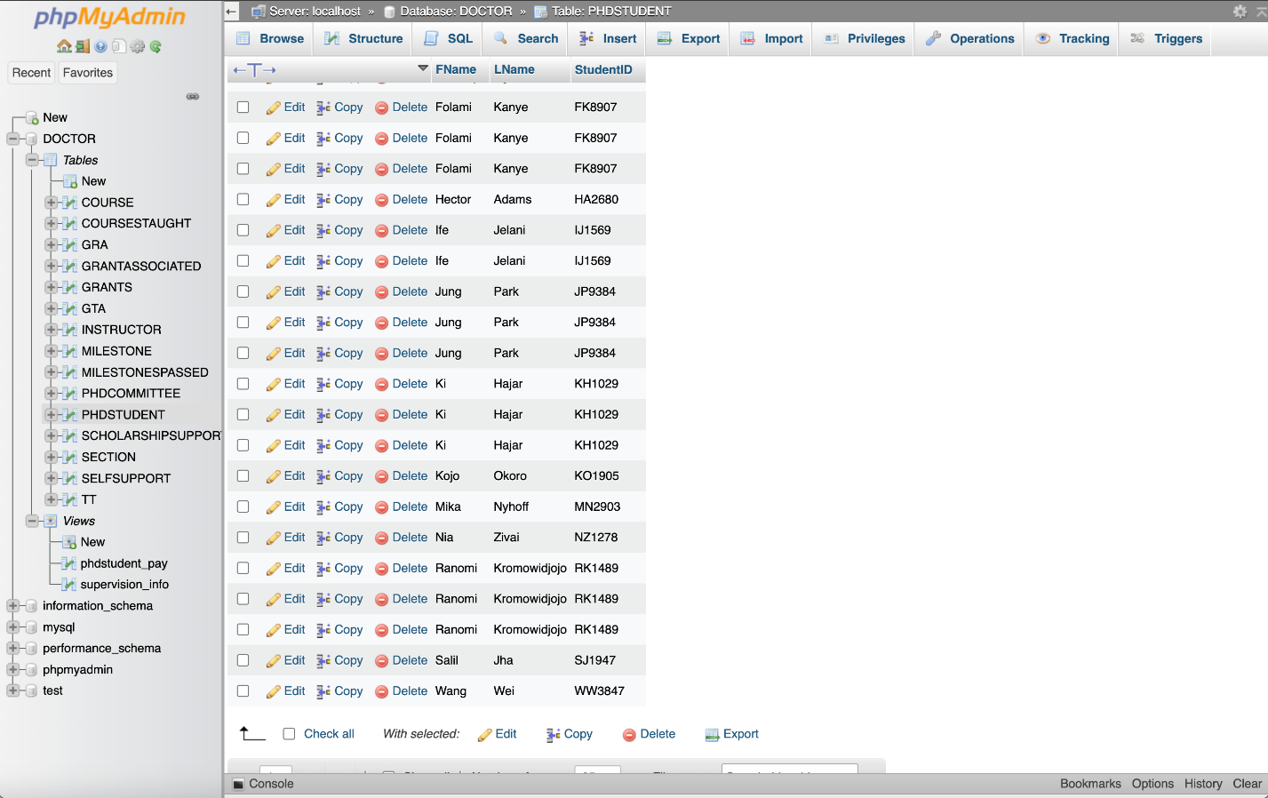

**5xiv**

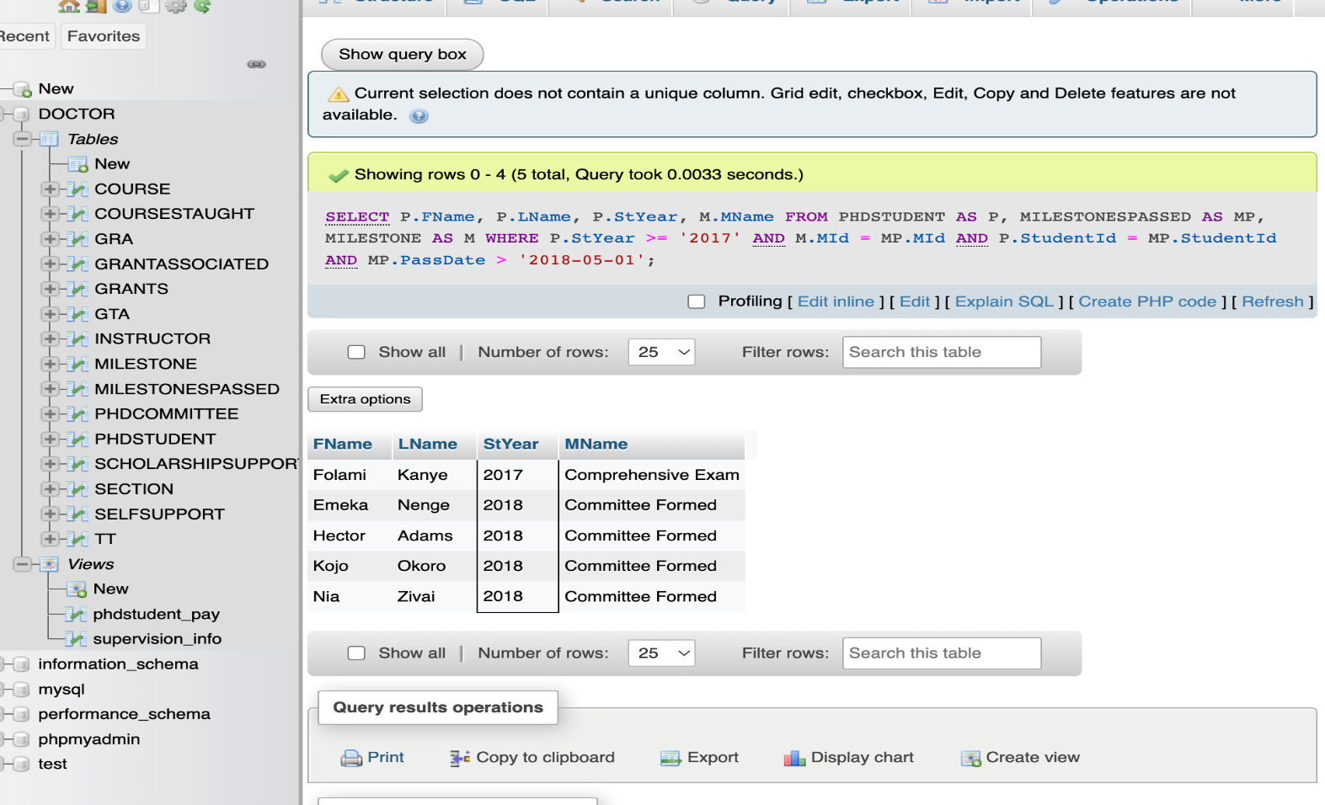

**5xv**

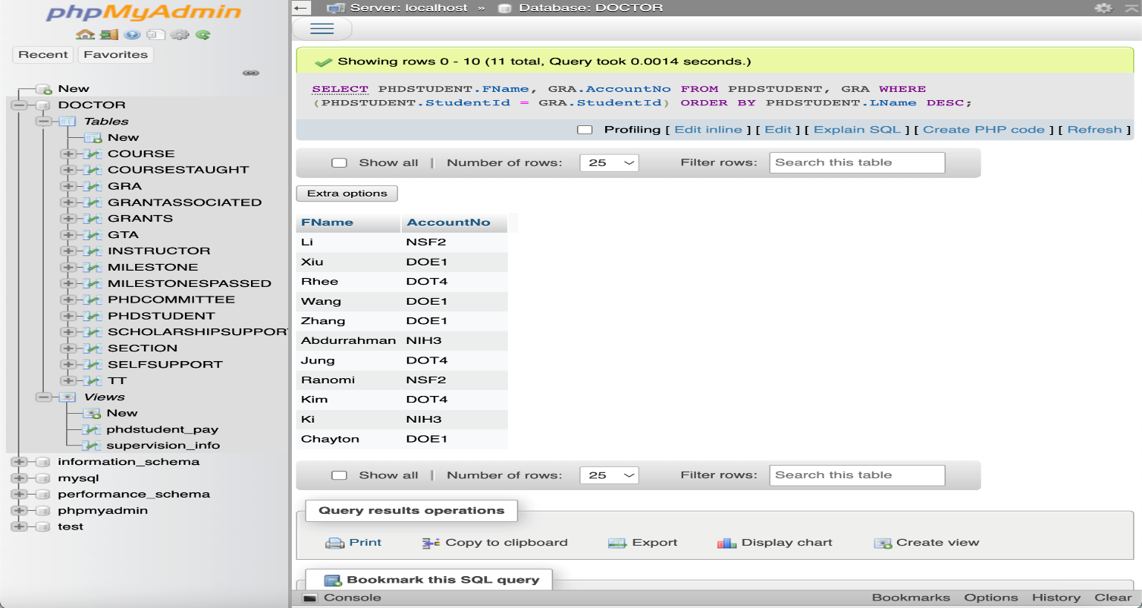

**5XV.**

**Student and their funding.**

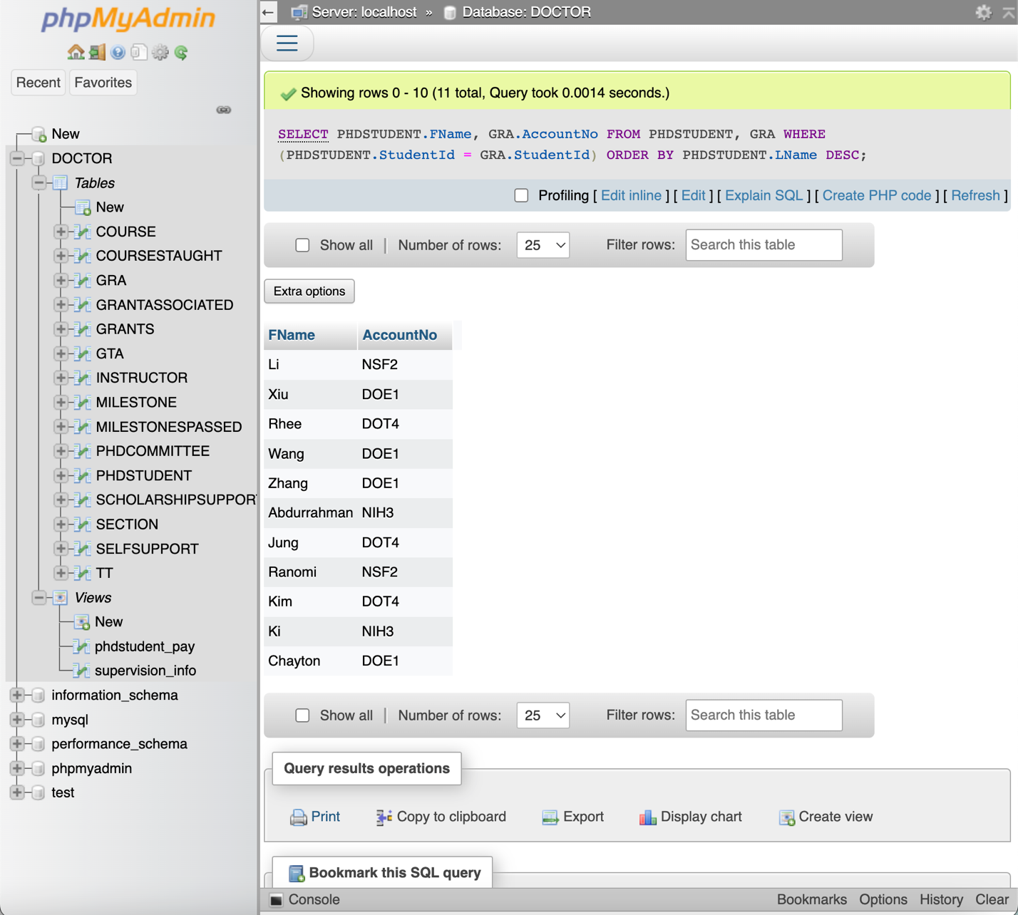

**Honor Code**

**I pledge, on my honor, to uphold UT Arlington's tradition of academic integrity, a tradition that values hard work and honest effort in the pursuit of academic excellence.**

**I promise that I will submit only work that I personally create or that I contribute to group collaborations, and I will appropriately reference any work from other sources. I will follow the highest standards of integrity and uphold the spirit of the Honor Code.**

 

**________________ _______________**

**Aditya Mishra Jose Aguilar**